TBD – The Best Deals
WebService Documentation
Last Update: 12-July-2017

Table of Contents
1 Basket 3
1.1 Add Product to Basket 4
1.2 Remove from Basket 5
1.3 Get the Basket count 6
1.4 Get the Basket list 7
1.5 Get the Basket landing page details 7
1.6 Get the Brand lists 9
1.7 Get alternate Price pagination and Price order 10
1.8 Update the Basket Count 11
1.9 Get Basket Product count 12
1.10 Remove User Basket 13
2 Categories 14
2.1 List the Categories 14
3 Content 15
3.1 WS to show Terms and Conditions, Privacy Policy, About Us, FAQ 15
3.2 WS to get the Sliders 16
4 Filters 18
4.1 Save the Quick Shopping List 18
4.2 Get the Quick Shopping List 20
4.3 Remove from Quick Shopping List 21
4.4 Search in Quick Shopping List (Currently not using) 22
5 Notifications 22
5.1 Get Notification List 23
5.2 Delete Notification 24
5.3 Check User is outside of Preferred Location 25
5.4 Change Notification Settings 25
5.5 Get Notification Settings 26
6 Products 27
6.1 Get Product Details 28
6.2 Make Product Favourite/Remove from it 33
6.3 Get Store Details in the Product Page 34
6.4 Increase Share Count once a Share successfully done 35
6.5 Get the View count 36
6.6 Get the Share count 37
6.7 Get the Price Alert Products 37
6.8 Get the Favourite Products 39
6.9 Add Price Alert 41
6.10 Add Review & Rating 42
6.11 Get the Basket 42
6.12 All Deals/Hot Deals 44
6.13 List all Products 46
6.14 Report Abuse 50
6.15 Update Review and Rating 51
6.16 Get Price Chart Details 51
6.17 Delete Multiple Alerts 53
6.18 Price Comparison 53
6.19 Get Promotions 54
6.20 Get Promotion Products 55
6.21 Get Promotion Products 58
6.22 Get hot deals with ads 59
6.23 Get Advertisements 60
7 Search 61
7.1 Search 61
7.2 Search Product Categories by Product Name 62
7.3 Search Product based on Categories 63
8 Users 64
8.1 Login 65
8.2 Update FB Email if not found on Login 66
8.3 Check Email ID is available against the given FB ID 67
8.4 To check if FB Account already exists 68
8.5 To check if Email ID is present anywhere in the DB 69
8.6 To check the Preferred Location is set 69
8.7 To SAVE the Preferred Location 70
8.8 Get the User Details 71
8.9 Set User Settings / Notification Settings 72
8.10 Get User Settings / Notification Settings 73
8.11 Update Profile Settings 74
8.12 Logout and REMOVE the device token 76
8.13 Change Password 77
8.14 Forgot Password 78
8.15 Registration 79
8.16 States 81
9 Wishlist 82
9.1 List the Wishlist for a particular User 83
9.2 Get Wishlist Product 83
9.3 Delete Wishlist 85
9.4 Delete Wishlist Product 85
9.5 Create Wish List 86
9.6 Update a Wishlist 87
9.7 Add Product to Wishlist 88
9.8 Delete Multiple Wishlists 88
10 Retailers 89
10.1 List all the Retailers 89
10.2 Save User Preference 90
10.3 Get User Preference 91
10.4 Save Store 91
10.5 Save preferences 92
10.6 Get retailer stores 93
11 Loyalty Prodcuts 94
11.1 Get Loyalty Comsumptions 94
11.2 Loyalty Product Listing 95
11.3 Save Users rating for the Loyalty Product 97
11.4 Save Users Review and Rating for the Loyalty Product 97
11.5 Get Reviews and Rating for the Loyalty Product 98
11.6 Share Loyalty Product 99
11.7 Add Loyalty Product into Cart 100
11.8 Get Cart Product Listing 100
11.9 Remove Product(s) from Cart 103
11.10 Place Loyalty Order 103
12 Chatbot 104
12.1 Chatbot Search Product categories 106
12.2 Chatbot Search Product by Category and Brand 112
12.3 Chatbot Get Product Stores 113
13 Check-In 115
13.1 Get Store Listing for Check-In 115
13.2 Do Check-In in particular Store 116



Basket
1) Add product to basket (http://thebestdeals.co.za/webservices/basket/add_to_basket)
2) Remove from basket (http://thebestdeals.co.za/webservices/basket/remove_from_basket)
3) Get the basket count (http://thebestdeals.co.za/webservices/basket/get_basket_count)
4) Get the basket list (http://thebestdeals.co.za/webservices/basket/get_basket_details)
5) Get the basket landing page details (http://thebestdeals.co.za/webservices/basket/get_basket_min_details)
---------------------------------------------------------------------------

Add Product to Basket [ Currently Not In Use ]
------
WS : http://thebestdeals.co.za/webservices/basket/add_to_basket
RAW: {"user_id":"77","product_id":"10162","special_id":"0","api_key":"7e53784e66dd87004a1d0e76ff195011", "product_count":"1","retailer_id":"47","store_id":"1209"}
http://thebestdeals.co.za/webservices/basket/add_to_basket_new
RAW: {"user_id":"77","product_id":"10162","special_id":"0","api_key":"7e53784e66dd87004a1d0e76ff195011", "product_count":"1","add_to_shopping_list":"yes","retailer_id":"47","store_id":"1209"}
success
--------
{
"status": "Success",
"basket_count": "2",
"message": "Product added to basket successfully"
}
Fail
-----
{
"status": "Fail",
"message": "Product already added to basket"
}

------------------------------------------------------------------------------------------------------------------------------------

WS : http://thebestdeals.co.za/webservices/basket/add_product_to_basket
RAW: {"user_id":"453","add_to_shopping_list":"no","product_count":"2","product_id":"11836","api_key":"7e53784e66dd87004a1d0e76ff195011","special_id":"99","retailer_id":"47", "store_id":"1209","remove_previous":"yes","retailer_id":"47","store_id":"1209"}
success
--------
{
"status": "Success",
"message": "Product added to basket successfully",
"basket_count": "1"
}
Fail
-----
{
"status": "Fail",
"message": "Product already added to basket"
}

------------------------------------------------------------------------------------------------------------------------------------
------------------------------------------------------------------------------------------------------------------------------------

Remove from Basket
-------------------
WS : http://thebestdeals.co.za/webservices/basket/remove_from_basket
RAW: {"user_id":"","product_id":"","retailer_id":"47","store_id":"1209","api_key": "7e53784e66dd87004a1d0e76ff195011"}

success
--------
{
"status": "Success",
"basket_count": "2",
"message": "Product removed successfully from basket"
}

Fail
-----
{
"status": "Fail",
"message": "Failed to remove product from basket"
}

------------------------------------------------------------------------------------------------------------------------------------
------------------------------------------------------------------------------------------------------------------------------------

Get the Basket count
---------------------
WS : http://thebestdeals.co.za/webservices/basket/get_basket_count
RAW: {"user_id":"","retailer_id":"47","store_id":"1209","api_key": "7e53784e66dd87004a1d0e76ff195011"}

success
--------
{
"status": "Success",
"basket_count": "2"
}

------------------------------------------------------------------------------------------------------------------------------------
------------------------------------------------------------------------------------------------------------------------------------

Get the Basket list
---------------------
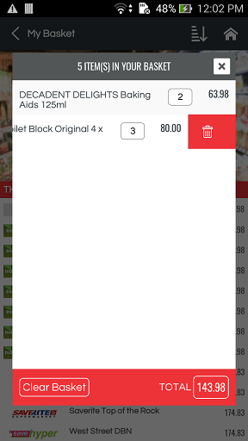
WS : http://thebestdeals.co.za/webservices/basket/get_basket_details
RAW: {"user_id":"","api_key": "7e53784e66dd87004a1d0e76ff195011"}

success
--------
{
"status": "Success",
"basket_details": [
{
"Id": "3691",
"ProductName": "Harvestime Frozen Potato Chips Straight Cut 2Kg",
"ProductImage": "http://thebestdeals.co.za/assets/images/products/medium/HARVESTIME_FROZEN_POTATO_CHIPS_STRAIGHT_CUT_2KG.jpg",
"Price": "50.00"
}
]
}

Get the Basket landing page details
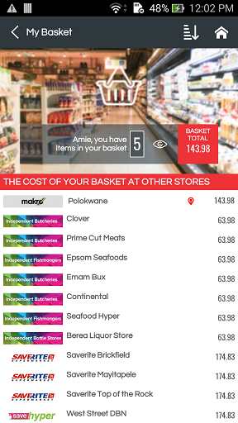

WS : http://thebestdeals.co.za/webservices/basket/get_basket_min_details
RAW: {"user_id":"77","retailer_id":43,"store_type_id":"50","store_id":"494","api_key":"7e53784e66dd87004a1d0e76ff195011"}

success
--------
{
"store_details": {
"StoreName": "Westwood Mall",
"Latitude": "-29.83510017",
"Longitude": "30.96759987",
"StreetAddress": "16 Lincoln Terrace Shop UL016 Sherwood",
"Zip": "4091",
"ContactPersonNumber": "0861 426 114",
"StateName": "KwaZulu Natal",
"LogoImage": "http://thebestdeals.co.za/assets/images/retailers/small/Game.jpg",
"StoreTime": {
"Day": "Thursday",
"OpenTime": "09:00",
"CloseTime": "21:00"
}
},
"status": "Success",
"basket_details": {
"total_count": "1",
"price_sum": "18.00",
"other_stores": [
{
"CompanyName": "SPAR",
"StoreName": "1000 Hills SPAR ",
"Price": "20.00",
"LogoImage": "http://thebestdeals.co.za/admin/../assets/images/retailers/medium/Spar.jpg"
},
{
"CompanyName": "SPAR",
"StoreName": "Adams",
"Price": "20.00",
"LogoImage": "http://thebestdeals.co.za/admin/../assets/images/retailers/medium/Spar.jpg"
}
]
}
}

Get the Brand lists
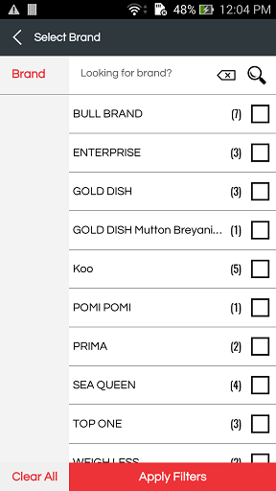

WS : http://thebestdeals.co.za/webservices/basket/get_brand_list
RAW: {"user_id":"77","retailer_id":43,"store_type_id":"50","store_id":"494","category_id":"2","api_key":"7e53784e66dd87004a1d0e76ff195011"}

success
--------
{
"status": "Success",
"brand_details": [
{
"Brand": "Albany",
"product_count": "6",
"available_distance": "4.1026520345719275",
"PrefDistance": "98"
},
{
"Brand": "AmulA",
"product_count": "1",
"available_distance": "4.1026520345719275",
"PrefDistance": "98"
}
]
}

fail
------
{
"status": "Fail",
"brand_details": []
}

------------------------------------------------------------------------------------------------------------------------------------
------------------------------------------------------------------------------------------------------------------------------------

Get alternate Price pagination and Price order
---------------------
WS : http://thebestdeals.co.za/webservices/basket/get_alternate_price
RAW: {"user_id":"77","retailer_id":43,"page_number":"","price_order":"h-l","api_key":"7e53784e66dd87004a1d0e76ff195011"}

success
--------
{
"status": "Success",
"basket_details": {
"total_pages": 9,
"current_page": 1,
"other_stores": [
{
"CompanyName": "SPAR",
"StoreName": "1000 Hills SPAR ",
"Price": "46.00",
"LogoImage": "http://thebestdeals.co.za/admin/../assets/images/retailers/medium/Spar.jpg"
},
{
"CompanyName": "SPAR",
"StoreName": "Ballito SPAR ",
"Price": "46.00",
"LogoImage": "http://thebestdeals.co.za/admin/../assets/images/retailers/medium/Spar.jpg"
}
]
}
}

fail
------
{
"status": "Success",
"basket_details": {
"total_pages": 0,
"current_page": 1,
"other_stores": []
}
}

------------------------------------------------------------------------------------------------------------------------------------
------------------------------------------------------------------------------------------------------------------------------------

Update the Basket Count
---------------------
WS : http://thebestdeals.co.za/webservices/basket/edit_basket_count
RAW: {"user_id":"77","basket_id":"","product_count":"","api_key":"7e53784e66dd87004a1d0e76ff195011"}

success
--------
{
"status": "Success",
"message": "Basket updated successfully",
"basket_count": 5,
}

fail
------
{
"status": "Fail",
"message": "Failed to update basket",
}

Get Basket Product count
WS : http://thebestdeals.co.za/webservices/basket/get_basket_product_count
RAW: {"user_id":"77","product_id":"","api_key":"7e53784e66dd87004a1d0e76ff195011"}

success
--------
{

}

fail
------
{

}
Get basket product count new
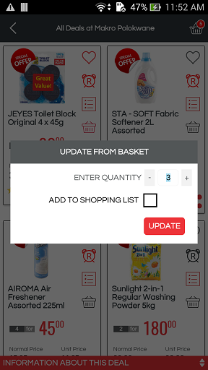

WS :http://thebestdeals.co.za/webservices/basket/get_basket_product_count_new
RAW: {"product_id":"11836","api_key":"7e53784e66dd87004a1d0e76ff195011","user_id":"77","special_id":"99","retailer_id":"47", "store_id":"1209"}
Please note
'isPresent' = 1 means products from another retailer is present in Basket.
So we need to show popup "We currently not allow to add products from multiple retailers at this moment."
success
--------
{
"status": "Success",
"count": "0",
"isPresent": 1
}

Remove User Basket
WS : http://thebestdeals.co.za/webservices/basket/remove_user_basket
RAW: {"user_id":"77","api_key":"7e53784e66dd87004a1d0e76ff195011"}

success
--------
{

}

fail
------
{

}

Categories
1) List the categories (http://thebestdeals.co.za/webservices/categories/list)

------------------------------------------------------------------------------

List the Categories
-----------------------------------------------------------------
Show contents
------
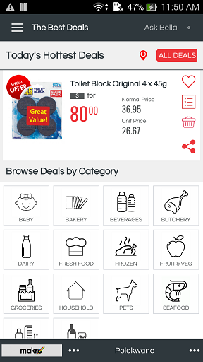
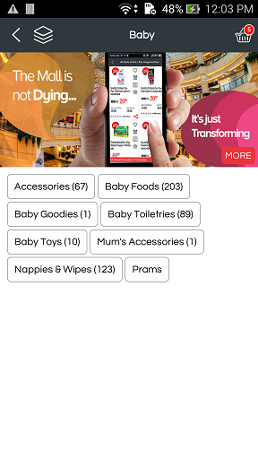
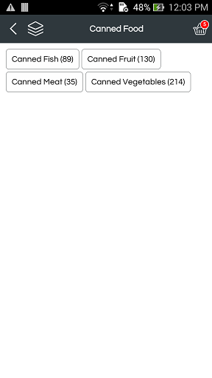
WS : http://thebestdeals.co.za/webservices/categories/list
RAW: {"user_id":"77","category_id":"","level": 0,"retailer_id":43,"store_id": 494,"api_key":"7e53784e66dd87004a1d0e76ff195011"}

success
--------
{
"status": "Success",
"categories": [
[
{
"Id": "250",
"CategoryName": "Baby",
"ParentCategory": "0",
"CategoryIcon": "http://thebestdeals.co.za/assets/images/categories/large/baby.gif",
"IsActive": "1"
},
{
"Id": "1",
"CategoryName": "Bakery",
"ParentCategory": "0",
"CategoryIcon": "http://thebestdeals.co.za/assets/images/categories/large/bakery.gif",
"IsActive": "1"
}
]
]
}

Content
1) WS to show Terms and conditions, Privacy Policy, About Us, FAQ (http://thebestdeals.co.za/webservices/content/get_content)

-------------------------------------------------------------------------------

WS to show Terms and Conditions, Privacy Policy, About Us, FAQ
-----------------------------------------------------------------

Show contents
------
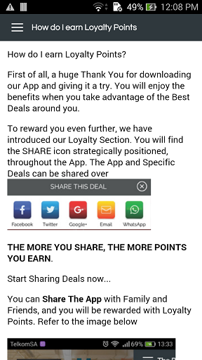


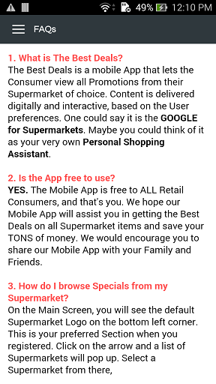
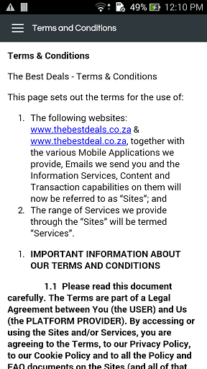
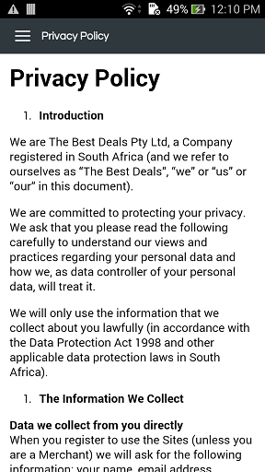
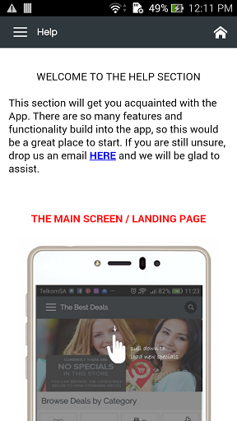
WS : http://thebestdeals.co.za/webservices/content/get_content
RAW: {"menu_id":3,"api_key": "7e53784e66dd87004a1d0e76ff195011"}

Menu ID for various content
---------------------------
Terms and Conditions - 1
PrivacY PolicY - 2
About Us - 3
faq - 4

success
--------
{
"status":"Success",
"content":
{
"Content":"
<img src=\"http:\/\/www.thebestdeals.co.za\/assets\/images\/content_upload\/Hydrangeas.jpg\" alt=\"\" width=\"162\" height=\"162\" \/>&nbsp;
<br \/>
<br \/>
<br \/>About Us
<br \/>
<br \/>
<br \/>&nbsp;hghgfhhdgdghdhgddhgfhfhgfdgdfhfhfhytryututuytuyetutyutyutyuueueueuetueuetuetyutyu
<br \/>
<br \/>
<a title=\"google\" href=\"http:\/\/www.thebestdeals.co.za\/admin\/content\/edit\/google.com\" target=\"_blank\">google.com<\/a>"
}
}

WS to get the Sliders

Show contents
------
WS : http://thebestdeals.co.za/webservices/content/get_front_slider
RAW: {"api_key": "7e53784e66dd87004a1d0e76ff195011"}

success
-------
{
"status": "Success",
"slider": [
{
"Id": "4",
"Image": "http://thebestdeals.co.za/admin/../assets/images/mobile_sliders/1f2dedd51cf77c58db3ec51c091d2688.jpg",
"Text": "Second slider text",
"Color": "#018988"
},
{
"Id": "3",
"Image": "http://thebestdeals.co.za/admin/../assets/images/mobile_sliders/68c25a5014461d18b5addbf8e8c34f00.jpg",
"Text": "First slider text",
"Color": "#ff0505"
},
{
"Id": "5",
"Image": "http://thebestdeals.co.za/admin/../assets/images/mobile_sliders/adde0c56f5fbdc6b772ee6ccdb01a35a.jpg",
"Text": "Third slider text",
"Color": "#ffa800"
}
]
}

Filters
1) Save the quick shopping list(http://thebestdeals.co.za/webservices/filters/save_shopping_list)
2) Get the quick shopping list(http://thebestdeals.co.za/webservices/filters/get_shopping_list)
3) Remove from quick shopping list(http://thebestdeals.co.za/webservices/filters/delete_quick_list)
4) Search in quick shopping list(http://thebestdeals.co.za/webservices/filters/quickshopping_list)

-----------------------------------------------------------------------------------------------------------------------

Save the Quick Shopping List
--------------------------------------------------

WS : http://thebestdeals.co.za/webservices/filters/save_shopping_list
RAW: {
"user_id":"77",
"shopping_list":[
{
"name":"Pakco Curried Chillies 350g",
"product_id":"3696",
"retailer_id":"43",
"store_type_id":"50",
"store_id": "494",
"count":"1",
"bought":"0"
},
{
"name":"Orange Grove Fruit Juice Blend 1.5L",
"product_id":"28",
"retailer_id":"43",
"store_type_id":"50",
"store_id": "494",
"count":"1",
"bought":"0"
}
],
"api_key":"7e53784e66dd87004a1d0e76ff195011"}

SUCCESS
-------
{
"status":"Success"
}

Fail
-------
{
"status":"Fail"
}

----------------------------------------------------------------------------------
----------------------------------------------------------------------------------

Get the Quick Shopping List
--------------------------------------------------
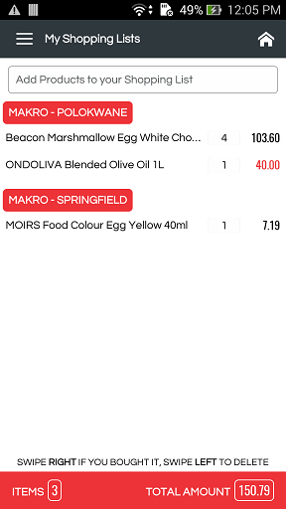
WS : http://thebestdeals.co.za/webservices/filters/get_shopping_list
RAW: {"user_id":"77","api_key":"7e53784e66dd87004a1d0e76ff195011"}

SUCCESS
-------
{
"status": "Success",
"shopping_list": [
{
"name": "Pakco Curried Chillies 350g",
"product_id": "3696",
"retailer_id": "43",
"store_type_id": "50",
"store_id": "494",
"count": "1",
"is_special": "1",
"price": "33.00"
},
{
"name": "Orange Grove Fruit Juice Blend 1.5L",
"product_id": "28",
"retailer_id": "43",
"store_type_id": "50",
"store_id": "494",
"count": "1",
"is_special": "0",
"price": "19.99"
}
]
}

Fail
-------
{
"status": "Fail",
"shopping_list": []
}

----------------------------------------------------------------------------------
----------------------------------------------------------------------------------

Remove from Quick Shopping List
--------------------------------------------------

WS : http://thebestdeals.co.za/webservices/filters/delete_quick_list
RAW: {"user_id":"212","product_id":"1085","api_key":"7e53784e66dd87004a1d0e76ff195011"}

SUCCESS
-------
{
"status": "Success",
"message": "Item removed successfully"
}

Fail
-------
{
"status": "Fail",
"message": "Failed to remove item"
}

----------------------------------------------------------------------------------
----------------------------------------------------------------------------------

Search in Quick Shopping List (Currently not using)
--------------------------------------------------

WS : http://thebestdeals.co.za/webservices/filters/quickshopping_list
RAW: {"user_id":"212","shopping_list":"","retailer_id":"","api_key":"7e53784e66dd87004a1d0e76ff195011"}

Notifications
1) Get notification list(http://thebestdeals.co.za/webservices/notifications/list)
2) Delete notification(http://thebestdeals.co.za/webservices/notifications/delete)
3) Check user is outside of preferred location (http://thebestdeals.co.za/webservices/notifications/check_location_change)

--------------------------------------------------------------------------------------------------------------------------------

Get Notification List
------
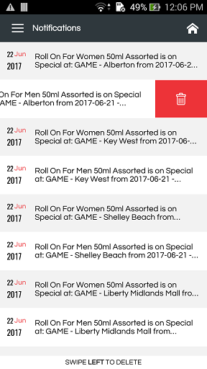
WS : http://thebestdeals.co.za/webservices/notifications/list
RAW: {"user_id":167,"api_key": "7e53784e66dd87004a1d0e76ff195011"}

success
--------
{
"status": "Success",
"notifications": [
{
"Id": "18",
"Message": "The price of your favorite product Albany Superior White Bread has been changed.",
"UserId": "167",
"CreatedOn": "03/10/2016"
},
{
"Id": "24",
"Message": "The price of your favorite product Albany Superior White Bread has been changed.",
"UserId": "167",
"CreatedOn": "03/10/2016"
},
{
"Id": "30",
"Message": "The price of your favorite product Albany Superior White Bread has been changed.",
"UserId": "167",
"CreatedOn": "03/10/2016"
},
{
"Id": "44",
"Message": "The price of your favorite product Albany Superior White Bread has been changed.",
"UserId": "167",
"CreatedOn": "03/10/2016"
}
]
}

Fail
-----
{
"status": "Success",
"notifications": []
}

---------------------------------------------------------------------------------------------------------------
---------------------------------------------------------------------------------------------------------------

Delete Notification
------
WS : http://thebestdeals.co.za/webservices/notifications/delete
RAW: {"id":18,"api_key": "7e53784e66dd87004a1d0e76ff195011"}

success
--------
{
"status": "Success"
}

---------------------------------------------------------------------------------------------------------------
---------------------------------------------------------------------------------------------------------------

Check User is outside of Preferred Location
------
WS : http://thebestdeals.co.za/webservices/notifications/check_location_change
RAW: {"user_id":"77","device_token":"","latitude":-29.803281,"longitude":31.014061,"api_key":"7e53784e66dd87004a1d0e76ff195011"}

success
--------
{
"status": "Success",
"message": "You are outside of the preferred location"
}

Fail
------
{
"status": "Fail",
"message": "You are inside of the preferred location"
}

Change Notification Settings

WS : http://thebestdeals.co.za/webservices/notifications/change_notification_settings
RAW: {"user_id":"77","price_change":"1","location_change":"1","near_store":"1",specials:"1",preferred_store_only:"1","api_key":"7e53784e66dd87004a1d0e76ff195011"}

success
--------
{
"status": "Success",
"message": "Notification settings updated successfully"
}

Fail
------
{
"status": "Fail",
"message": "Failed to update notification settings"
}

Get Notification Settings
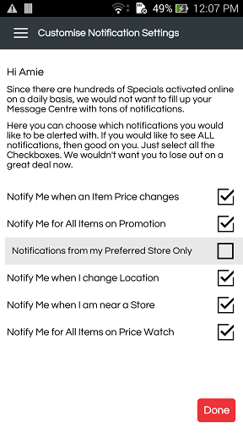
WS : http://thebestdeals.co.za/webservices/notifications/get_notification_settings
RAW: {"user_id":"77","api_key":"7e53784e66dd87004a1d0e76ff195011"}

success
--------
{
"status": "Success",
"settings": {
"WishlistNotification": "1",
"FavoriteNotification": "1",
"OtherRetailer": "0",
"PriceChange": "1",
"LocationChange": "0",
"NearStore": "0",
"Specials": "1",
"PreferredStoreOnly": "1"
}
}

Products
1) Get product details (http://thebestdeals.co.za/webservices/products/product_details)
2) Make product favourite/remove from it (http://thebestdeals.co.za/webservices/products/make_product_favorite)
3) Get store details in the product page (http://thebestdeals.co.za/webservices/products/get_product_store)
4) Increase share count once a share successfully done (http://thebestdeals.co.za/webservices/products/add_share_count)
5) Get the view count (http://thebestdeals.co.za/webservices/products/get_view_count)
6) Get the share count (http://thebestdeals.co.za/webservices/products/get_share_count)
7) Get the price alerted products (http://thebestdeals.co.za/webservices/products/list_alert_products)
8) Get the favourite products (http://thebestdeals.co.za/webservices/products/list_favorite_products)
9) Add price alert (http://thebestdeals.co.za/webservices/products/add_product_alert)
10) Add review & rating (http://thebestdeals.co.za/webservices/products/add_review_rating)
11) Get the basket (http://thebestdeals.co.za/webservices/products/get_basket)
12) All deals (http://thebestdeals.co.za/webservices/products/hot_deals)
13) List all products (http://thebestdeals.co.za/webservices/products/list)
Newly created (http://thebestdeals.co.za/webservices/products/get_product_list)
14) Report abuse (http://thebestdeals.co.za/webservices/products/report_abuse)
15) Update review and rating (http://thebestdeals.co.za/webservices/products/update_review_rating)
16) Get price chart details (http://thebestdeals.co.za/webservices/products/get_chart_details)
17) Delete multiple alerts
18) Price comparision of the product.
19) Get Promotions (http://thebestdeals.co.za/webservices/products/get_promotions)
20) Get Promotion Products (http://thebestdeals.co.za/webservices/products/get_promotion_products )
--------------------------------------------------------------------------------------------------------------------------------

Get Product Details
--------------------
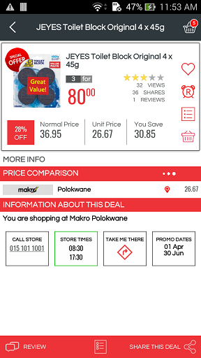
WS : http://thebestdeals.co.za/webservices/products/product_details
RAW: {"store_id":"494", "store_type_id":"50", "user_id":"77", "product_id":"79", "retailer_id":"43", "api_key":"7e53784e66dd87004a1d0e76ff195011","device_type" :"A"}
Note : "device_type" :"A" [ "A" : Android, "I" : Apple ]

success
--------
{
"status": "Success",
"product": [
{
"Id": "79",
"ProductName": "Albany Superior White Bread 700g",
"ProductImage": "http://thebestdeals.co.za/assets/images/products/medium/ALbany-superior-bread-white.jpg",
"ProductDescription": "Albany Superior White Bread 700g",
"RRP": "12.99",
"Brand": "Albany",
"SKU": "0000",
"BasketId": "128",
"reviews_count": "6",
"avg_rating": "2.6666666666666665",
"is_favorite": "1",
"store_price": "13.00",
"price_alert": "0",
"SpecialQty": "3",
"SpecialPrice": "20.00",
"PriceAppliedFrom": "2016-10-26",
"PriceAppliedTo": "2016-11-30",
"PageUrl": "http://www.thebestdeals.co.za/productdetails/Albany+Superior+White+Bread+700g/xbWcJZCwEOTbGZWD3NFbzMxxU613CvgAaaLpOMhM06O8J11viiWaDL2pV1KQakFogY1o4T8d.3hYfH6ALIYnTg--",
"shares": "6",
"views": "1.11K"
}
],
"is_review_added": 1,
"reviews": [
{
"Id": "70",
"Review": " ",
"Rating": "0",
"CreatedOn": "5 days ago",
"UserId": "77",
"FirstName": "AmiiE",
"LastName": "JaksoN",
"ProfileImage": "http://thebestdeals.co.za/assets/images/users/medium/boss-512.png"
},
{
"Id": "68",
"Review": "gjjnn",
"Rating": "5",
"CreatedOn": "1 week ago",
"UserId": "217",
"FirstName": "Val Daliah",
"LastName": " ",
"ProfileImage": "http://thebestdeals.co.za/assets/images/users/default.jpg"
},
{
"Id": "64",
"Review": "test",
"Rating": "1",
"CreatedOn": "1 week ago",
"UserId": "212",
"FirstName": "Aliah Tester",
"LastName": " ",
"ProfileImage": "http://thebestdeals.co.za/assets/images/users/default.jpg"
},
{
"Id": "52",
"Review": "Good product",
"Rating": "5",
"CreatedOn": "1 month ago",
"UserId": "167",
"FirstName": "Arun Sankar",
"LastName": "S",
"ProfileImage": "http://thebestdeals.co.za/assets/images/users/medium/Lighthouse.jpg"
},
{
"Id": "29",
"Review": "Average product",
"Rating": "2",
"CreatedOn": "1 year ago",
"UserId": "101",
"FirstName": "Genknooz",
"LastName": "First",
"ProfileImage": "http://thebestdeals.co.za/assets/images/users/medium/user_group-512.png"
},
{
"Id": "23",
"Review": "Eatable product",
"Rating": "3",
"CreatedOn": "1 year ago",
"UserId": "106",
"FirstName": "John",
"LastName": "Dind",
"ProfileImage": "http://thebestdeals.co.za/assets/images/users/default.jpg"
}
],
"related_products": [
{
"Id": "1085",
"ProductName": "Bakers Bread White Bread Sliced 700g",
"ProductImage": "http://thebestdeals.co.za/assets/images/products/medium/default.jpg",
"ProductDescription": "Bakers Bread White Bread Sliced 700g",
"RRP": "14.99",
"Brand": "Bakers Bread",
"SKU": "",
"reviews_count": "0",
"avg_rating": null,
"store_price": "0.00",
"CategoryId": "3",
"CategoryName": "White Bread",
"SpecialQty": "1",
"SpecialPrice": "11.99"
},
{
"Id": "3700",
"ProductName": "Albany Superior Low Gi Sliced Brown Seed Bread 700",
"ProductImage": "http://thebestdeals.co.za/assets/images/products/medium/Albany_Superior_Low_Gi_Sliced_Brown_Seed_Bread_700g_2.jpg",
"ProductDescription": "Albany Superior Low Gi Sliced Brown Seed Bread 700g",
"RRP": "15.99",
"Brand": "Albany",
"SKU": "",
"reviews_count": "2",
"avg_rating": "0.5",
"store_price": "16.00",
"CategoryId": "0",
"CategoryName": null,
"SpecialQty": "1",
"SpecialPrice": "11.90"
}
],
"store_products": [
{
"distance": "7086.702861438287",
"Id": "32",
"CompanyName": "SPAR",
"LogoImage": "http://thebestdeals.co.za/assets/images/retailers/medium/spar_logo-300B.jpg",
"Price": "130.00",
"SpecialQty": "0",
"SpecialPrice": "0",
"StoreName": "A Store Name Test One"
},
{
"distance": "7094.702893402189",
"Id": "33",
"CompanyName": "Shoprite SA",
"LogoImage": "http://thebestdeals.co.za/assets/images/retailers/medium/Shoprite2.jpg",
"Price": "13.00",
"SpecialQty": "0",
"SpecialPrice": "0",
"StoreName": "Live Store"
},
{
"distance": "8.787199425716588",
"Id": "42",
"CompanyName": "Genknooz test shop",
"LogoImage": "http://thebestdeals.co.za/assets/images/retailers/medium/Desert.jpg",
"Price": "10.00",
"SpecialQty": "0",
"SpecialPrice": "0",
"StoreName": "Genknooz Shop"
}
],
"store_details": {
"StoreName": "Westwood Mall",
"Latitude": "-29.8351",
"Longitude": "30.9676",
"StreetAddress": "16 Lincoln Terrace Shop UL016 Sherwood",
"Zip": "4091",
"ContactPersonNumber": "0861 426 114",
"StateName": "KwaZulu Natal",
"LogoImage": "http://thebestdeals.co.za/assets/images/retailers/small/gamelogo-jpg.jpg",
"StoreTime": {
"Day": "Friday",
"OpenTime": "09:00",
"CloseTime": "21:00"
}
}
}

-----------------------------------------------------------------------------------
-----------------------------------------------------------------------------------

Make Product Favourite/Remove from it
------
WS : http://thebestdeals.co.za/webservices/products/make_product_favorite
RAW: {"user_id":212,"product_id":"","api_key": "7e53784e66dd87004a1d0e76ff195011"}

success
--------
if added to favorite

{
"status": "Success",
"is_favorite": "1",
"message": "Product added to favorite list"
}

if removed from favorite

{
"status": "Success",
"is_favorite": "0",
"message": "Product removed from favorite list"
}

Fail
-----
{
"status": "Fail"
}

------------------------------------------------------------------------------------
------------------------------------------------------------------------------------

Get Store Details in the Product Page
------
WS : http://thebestdeals.co.za/webservices/products/get_product_store
RAW: {"store_id":"494","user_id":"77","retailer_id":"43","api_key":"7e53784e66dd87004a1d0e76ff195011"}

success
--------
{
"status": "Success",
"store_details": {
"StoreName": "Westwood Mall",
"Latitude": "-29.8351",
"Longitude": "30.9676",
"StreetAddress": "16 Lincoln Terrace Shop UL016 Sherwood",
"Zip": "4091",
"ContactPersonNumber": "0861 426 114",
"StateName": "KwaZulu Natal",
"LogoImage": "http://thebestdeals.co.za/assets/images/retailers/small/gamelogo-jpg.jpg",
"StoreTime": {
"Day": "Friday",
"OpenTime": "09:00",
"CloseTime": "21:00"
}
}
}

Fail
-----
{
"status": "Fail",
"store_details": []
}

------------------------------------------------------------------------------------
------------------------------------------------------------------------------------

Increase Share Count once a Share successfully done
------
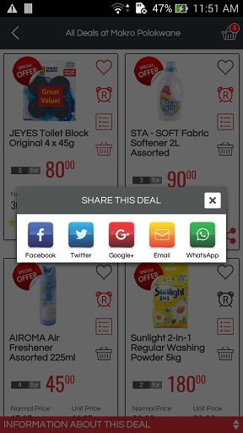
WS : http://thebestdeals.co.za/webservices/products/add_share_count
RAW: {"retailer_id":"43","store_id":"494","product_id":"28","user_id":"212","share_from":"A","api_key":"7e53784e66dd87004a1d0e76ff195011"}

success
--------
{
"status": "Success",
"count": "4",
"message": "Share count updated successfully"
}

Fail
-----
{
"status": "Fail",
"message": "Failed to update share count"
}

------------------------------------------------------------------------------------
------------------------------------------------------------------------------------

Get the View count
------
WS : http://thebestdeals.co.za/webservices/products/get_view_count
RAW: {"product_id":"28","user_id":"212","api_key":"7e53784e66dd87004a1d0e76ff195011"}

success
--------
{
"status": "Success",
"count": "185"
}

------------------------------------------------------------------------------------
------------------------------------------------------------------------------------

Get the Share count
------
WS : http://thebestdeals.co.za/webservices/products/get_share_count
RAW: {"product_id":"28","user_id":"212","api_key":"7e53784e66dd87004a1d0e76ff195011"}

success
--------
{
"status": "Success",
"count": "4"
}

------------------------------------------------------------------------------------
------------------------------------------------------------------------------------

Get the Price Alert Products
------
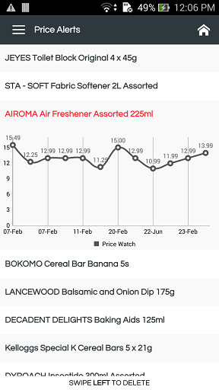
WS : http://thebestdeals.co.za/webservices/products/list_alert_products
RAW: {"user_id":"77","retailer_id":"43","api_key":"7e53784e66dd87004a1d0e76ff195011"}

success
--------
{
"status": "Success",
"alert_products": [
{
"Id": "80",
"ProductName": "Clover Butter Spread 500g",
"ProductImage": "http://thebestdeals.co.za/assets/images/products/medium/clover-no-artificial-ingredients.png",
"ProductDescription": "Clover Butter Spread 500g",
"RRP": "42.99",
"Brand": "Clover",
"SKU": "0000",
"reviews_count": "1",
"avg_rating": "4",
"is_favorite": "1",
"store_price": "43.00",
"SpecialQty": "0",
"SpecialPrice": "0"
},
{
"Id": "86",
"ProductName": "Freshly baked Rye Bread",
"ProductImage": "http://thebestdeals.co.za/assets/images/products/medium/new-york-brand-400x400.jpg",
"ProductDescription": "Freshly baked Rye Bread",
"RRP": "15.99",
"Brand": "Bakery",
"SKU": "0000",
"reviews_count": "3",
"avg_rating": "1.3333333333333333",
"is_favorite": "1",
"store_price": "16.00",
"SpecialQty": "0",
"SpecialPrice": "0"
}
]
}

Fail
-----
{
"status": "Fail",
"message": "No price alerts found",
"alert_products": []
}

------------------------------------------------------------------------------------
------------------------------------------------------------------------------------

Get the Favourite Products
------
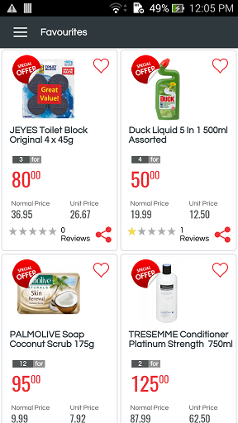
WS : http://thebestdeals.co.za/webservices/products/list_favorite_products
RAW: {"user_id":"77","retailer_id":"43","api_key":"7e53784e66dd87004a1d0e76ff195011",
"device_type" :"A"}
Note : "device_type" :"A" [ "A" : Android, "I" : Apple ]
success
--------
{
"status": "Success",
"favorite_products": [
{
"Id": "1085",
"ProductName": "Bakers Bread White Bread Sliced 700g",
"ProductImage": "http://thebestdeals.co.za/assets/images/products/medium/default.jpg",
"ProductDescription": "Bakers Bread White Bread Sliced 700g",
"RRP": "14.99",
"Brand": "Bakers Bread",
"SKU": "",
"reviews_count": "0",
"avg_rating": "0",
"store_price": "0.00",
"SpecialQty": "1",
"SpecialPrice": "11.99"
},
{
"Id": "18",
"ProductName": "Kelloggs Corn Flakes 750g",
"ProductImage": "http://thebestdeals.co.za/assets/images/products/medium/CornFlakes.jpg",
"ProductDescription": "Kelloggs Corn Flakes 750g",
"RRP": "29.90",
"Brand": "Kelloggs",
"SKU": "",
"reviews_count": "1",
"avg_rating": "3.5",
"store_price": "30.00",
"SpecialQty": "1",
"SpecialPrice": "25.60"
}
]
}

Fail
-----
{
"status": "Fail",
"message": "No favourites found",
"favorite_products": []
}

------------------------------------------------------------------------------------
------------------------------------------------------------------------------------

Add Price Alert
------
WS : http://thebestdeals.co.za/webservices/products/add_product_alert
RAW: {"product_id":"28","user_id":"212","api_key":"7e53784e66dd87004a1d0e76ff195011"}

if added
success
--------
{
"status": "Success",
"price_alert": "1",
"message": "Product added to alert list"
}

if remove
success
--------
{
"status": "Success",
"price_alert": "0",
"message": "Product removed from alert list"
}

fail
--------
{
"status": "Fail"
}

------------------------------------------------------------------------------------
------------------------------------------------------------------------------------

Add Review & Rating
------
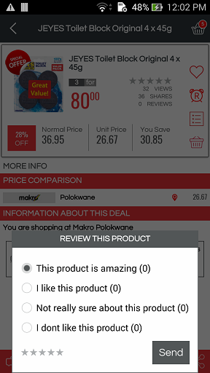
WS : http://thebestdeals.co.za/webservices/products/add_review_rating
RAW: {"user_id":"", "product_id":"", "review_comment":"", "review_rating":"", "api_key":"7e53784e66dd87004a1d0e76ff195011"}

success
--------
{
"status": "Success",
"message": "Review added successfully"
}

fail
--------
{
"status": "Fail",
"message": "Review already exists"
}

------------------------------------------------------------------------------------
------------------------------------------------------------------------------------

Get the Basket
------
WS : http://thebestdeals.co.za/webservices/products/get_basket
RAW: {"user_id":"", "retailer_id":"", "store_id":"", "api_key":"7e53784e66dd87004a1d0e76ff195011"}

success
--------
{
"status": "Success",
"products": [
{
"Id": "28",
"ProductName": "Orange Grove Fruit Juice Blend 1.5L",
"ProductImage": "http://thebestdeals.co.za/assets/images/products/medium/IDShot_540x540.jpg",
"Price": "19.99",
"SpecialQty": "1",
"SpecialPrice": "18.99"
},
{
"Id": "3696",
"ProductName": "Pakco Curried Chillies 350g",
"ProductImage": "http://thebestdeals.co.za/assets/images/products/medium/PAKCO_CURRIED_CHILLIES_350g.jpg",
"Price": "35.99",
"SpecialQty": "0",
"SpecialPrice": "0"
}
],
"basket_total_price": "849.34",
"other_retailer_products": [
{
"LogoImage": "http://thebestdeals.co.za/assets/images/retailers/medium/spar_logo-300B.jpg",
"Price": "24.00"
},
{
"LogoImage": "http://thebestdeals.co.za/assets/images/retailers/medium/spar_logo-300B.jpg",
"Price": "35.00"
}
]
}
------------------------------------------------------------------------------------
------------------------------------------------------------------------------------

All Deals/Hot Deals
------
WS : http://thebestdeals.co.za/webservices/products/hot_deals
RAW: {"page_number":"1", "user_id":"","retailer_id":"","store_id":"", "category_id":"", "longitude":"","latitude":"", "api_key":"7e53784e66dd87004a1d0e76ff195011","device_type" :"A" }
Note :
- Here "category_id" is an optional parameter , rest of the paremeters are mandatory.
- "device_type" :"A" [ "A" : Android, "I" : Apple ]
success
--------
{
"status": "Success",
"products": [
{
"Id": "5",
"ProductName": "Royalle Rusk Bread",
"ProductImage": "http://thebestdeals.co.za/assets/images/products/medium/Wheatman_Milk_Rusk___Toasted_Bread.jpg",
"ProductDescription": "Royalle Rusk Bread",
"RRP": "10.00",
"Brand": "Nestle",
"SKU": "",
"reviews_count": "2",
"avg_rating": "2.5",
"is_favorite": "0",
"store_price": "10.00",
"SpecialQty": "1",
"SpecialPrice": "10.00",
"BasketId": "",
"price_alert": "0",
"PriceAppliedFrom": "01Nov",
"PriceAppliedTo": "31Dec"
},
{
"Id": "1083",
"ProductName": "Bakers Bread Crushed Wheat Bread Low Gi Sliced 800",
"ProductImage": "http://thebestdeals.co.za/assets/images/products/medium/default.jpg",
"ProductDescription": "Bakers Bread Crushed Wheat Bread Low Gi Sliced 800g",
"RRP": "0.00",
"Brand": "Bakers Bread",
"SKU": "",
"reviews_count": "1",
"avg_rating": "4.5",
"is_favorite": "1",
"store_price": "0.00",
"SpecialQty": "1",
"SpecialPrice": "23.80",
"BasketId": "",
"price_alert": "0",
"PriceAppliedFrom": "01Nov",
"PriceAppliedTo": "31Dec"
}
]
}

fail
--------

------------------------------------------------------------------------------------
------------------------------------------------------------------------------------

List all Products
------
WS : http://thebestdeals.co.za/webservices/products/list
RAW: {"user_id":"77","retailer_id":"33","store_id":"580","store_type_id":"56","category_id":"336","keyword":"","page_number":"1","price_range":"",
"brands":[
{
"name": "Bakers"
},
{
"name": "Oreo"
}
],
"api_key":"7e53784e66dd87004a1d0e76ff195011"}

success
--------
{
"status": "Success",
"products": [
{
"Id": "1083",
"ProductName": "Bakers Bread Crushed Wheat Bread Low Gi Sliced 800",
"ProductImage": "http://thebestdeals.co.za/assets/images/products/medium/default.jpg",
"ProductDescription": "Bakers Bread Crushed Wheat Bread Low Gi Sliced 800g",
"RRP": "0.00",
"Brand": "Bakers Bread",
"SKU": "",
"reviews_count": "1",
"avg_rating": "4.5",
"is_favorite": "1",
"store_price": "0.00",
"SpecialQty": "1",
"SpecialPrice": "23.80",
"PageUrl" : ""
},
{
"Id": "1078",
"ProductName": "Bakers Brown Bread Sliced 700g",
"ProductImage": "http://thebestdeals.co.za/assets/images/products/medium/default.jpg",
"ProductDescription": "Bakers Brown Bread Sliced 700g",
"RRP": "14.99",
"Brand": "Bakers Bread",
"SKU": "",
"reviews_count": "0",
"avg_rating": "0",
"is_favorite": "0",
"store_price": "14.99",
"SpecialQty": "0",
"SpecialPrice": "0",
"PageUrl" : ""
}
],
"total_pages": 1,
"products_range": [
{
"min": 0,
"max": "0.00"
},
{
"min": "0.00",
"max": "30.00"
}
]
}

------------------------------------------------------------------------------------
------------------------------------------------------------------------------------
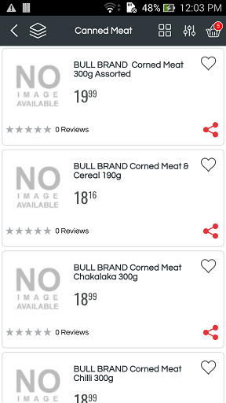
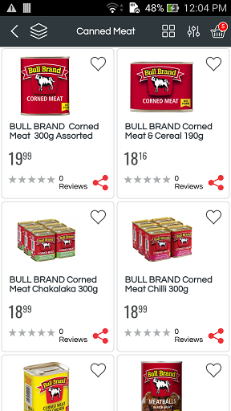
WS :http://thebestdeals.co.za/webservices/products/get_product_list

RAW: { "brands":"", "price_range":"" , "store_type_id":"56", "api_key":"7e53784e66dd87004a1d0e76ff195011", "keyword":"", "page_number":"1", "store_id":"18","category_id":"148","user_id":"77","retailer_id":"32","device_type" :"A"
}
Note : "device_type" :"A" [ "A" : Android, "I" : Apple ]
success
--------
{
"status": "Success",
"products": [
{
"pid": "14752",
"reviews_count": "0",
"avg_rating": "0",
"Id": "14752",
"ProductName": "ACE Instant Original Porridge 1kg",
"ProductImage": "http://thebestdeals.co.za/assets/images/products/medium/ACE_Instant_Original_Porridge_1kg.jpg",
"ProductDescription": "ACE Instant Original Porridge 1kg",
"RRP": "18.99",
"Brand": "ACE Instant Original Porridge 1kg",
"SKU": "",
"store_price": "18.99",
"SpecialQty": "0",
"SpecialPrice": "0",
"PriceAppliedFrom": "",
"PriceAppliedTo": "",
"IsStore": "0",
"special_id": "0",
"is_favorite": 0,
"PageUrl": "http://thebestdeals.co.za/productdetails/ACE+Instant+Original+Porridge+1kg/0w9afE5.D9l1Ev6okRWEzm1JUsT5G1XEJ232YccU8VrzyjlNLefe.3qBNo87fa741rYioct1wVr1ark~skxCDw--"
}
],
"total_pages": 17,
"current_page": "1",
"products_range": [
{
"min": 0,
"max": "0.00"
},
{
"min": "0.00",
"max": "30.00"
},
{
"min": "30.00",
"max": "60.00"
},
{
"min": "60.00",
"max": "90.00"
},
{
"min": "90.00",
"max": "120.00"
},
{
"min": "120.00 and above",
"max": 0
}
],
"basket_count": "8"
}

------------------------------------------------------------------------------------
------------------------------------------------------------------------------------

Report Abuse
------
WS : http://thebestdeals.co.za/webservices/products/report_abuse
RAW: {"user_id":"", "product_id":"", "message":"", "api_key":"7e53784e66dd87004a1d0e76ff195011"}

success
--------
{
"status":"Success",
"message": "Abuse report added successfully"
}

fail
--------
{
"status":"Success",
"message": "Abuse report already exists"
}

------------------------------------------------------------------------------------
------------------------------------------------------------------------------------

Update Review and Rating
------
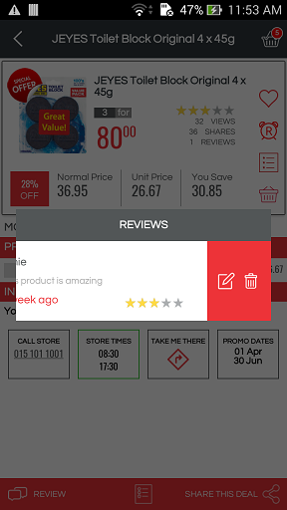
WS : http://thebestdeals.co.za/webservices/products/update_review_rating
RAW: {"user_id":"", "product_id":"", "review_comment":"", "review_rating":"", "api_key":"7e53784e66dd87004a1d0e76ff195011"}

success
--------
{
"status":"Success",
"message": "Review updated successfully"
}

fail
--------
{
"status":"Success",
"message": "Review updating failed"
}

------------------------------------------------------------------------------------
------------------------------------------------------------------------------------

Get Price Chart Details
------
WS : http://thebestdeals.co.za/webservices/products/get_chart_details
RAW: {"product_id":"9","api_key":"7e53784e66dd87004a1d0e76ff195011"}

success
--------
{
"status": "Success",
"day": [
"30-Oct",
"05-Dec",
"14-Dec",
"17-Dec"
],
"price": [
"15.49",
"15.00",
"12.99",
"13.75"
],
"store": [
{
"retailer": "GAME",
"store": ""
},
{
"retailer": "GAME",
"store": "Westwood Mall"
},
{
"retailer": "Shoprite Checkers",
"store": "Davenport Centre"
},
{
"retailer": "Food Lovers Market",
"store": "Berea Road"
}
]
}

fail
--------
{
"status": "Fail",
"day": [],
"price": [],
"store": []
}

Delete Multiple Alerts

WS : http://thebestdeals.co.za/webservices/products/delete_alerts
RAW: {"id":"1,2,3","api_key":"7e53784e66dd87004a1d0e76ff195011"}

success
--------
{
"status": "Success"
}

Price Comparison
WS : http://thebestdeals.co.za/webservices/products/compare_product
RAW: {"user_id":"77","product_id":"10485","api_key":"7e53784e66dd87004a1d0e76ff195011","retailer_id":"47","latitude":"-29.85868040","longitude":"31.02184040"}
success
--------
{
"status": "Success",
"store_products": [
{
"distance": "0.07660949147452942",
"Id": "46",
"CompanyName": "Save",
"LogoImage": "http://thebestdeals.co.za/assets/images/retailers/medium/Savehyper.jpg",
"Price": "26.45",
"SpecialQty": "0",
"SpecialPrice": "0",
"StoreName": "Church Street PMB"
},
{
"distance": "0.1164779505378289",
"Id": "44",
"CompanyName": "Woolworths",
"LogoImage": "http://thebestdeals.co.za/assets/images/retailers/medium/Woolworths3.jpg",
"Price": "26.45",
"SpecialQty": "0",
"SpecialPrice": "0",
"StoreName": "Kensington Drive"
}
]
}

Get Promotions

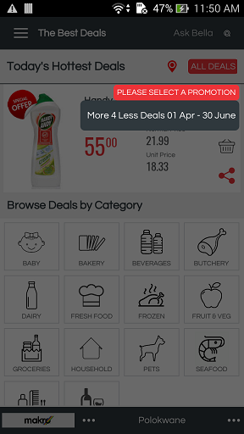
WS : http://thebestdeals.co.za/webservices/products/get_promotions
RAW: {"user_id":"77","retailer_id":"33","store_id":"539", "api_key":"7e53784e66dd87004a1d0e76ff195011"}
success
--------
{
"status": "Success",
"message": "Promotion(s) available",
"promotions": [
{
"special_id": "109",
"SpecialName": "More Deals KZN"
}
]
}

Fail
-----
{
"status": "Fail",
"message": "No Promotion(s) available",
"promotions": []
}

Get Promotion Products

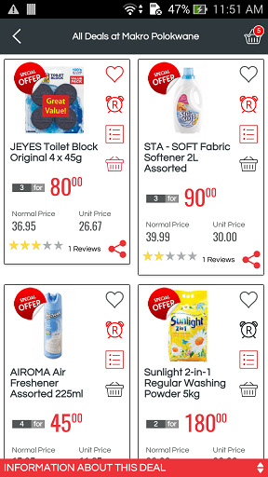

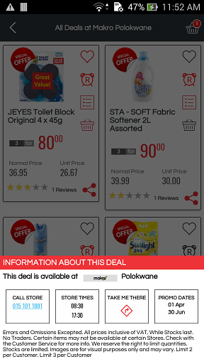
WS : http://thebestdeals.co.za/webservices/products/get_promotion_products
RAW: {"page_number":"1", "user_id":"77","retailer_id":"33","store_id":"539", "special_id":"109","api_key":"7e53784e66dd87004a1d0e76ff195011","device_type" :"A"}
Note : "device_type" :"A" [ "A" : Android, "I" : Apple ]
success
--------
{
"status": "Success",
"total_pages": 6,
"current_page": "1",
"products": [
{
"pid": "12627",
"reviews_count": "0",
"avg_rating": "0",
"wish_lists": "0",
"Id": "12627",
"ProductName": "Oreo Cookies 176g Box",
"ProductImage": "http://thebestdeals.co.za/assets/images/products/medium/Oreo_Cookies_176g_Box.jpg",
"ProductDescription": "Oreo Cookies 176g Box",
"RRP": "12.99",
"Brand": "OREO",
"SKU": "",
"store_price": "18.99",
"SpecialQty": "2",
"SpecialPrice": "28.00",
"BasketId": "",
"price_alert": "0",
"PriceAppliedFrom": "23 Apr",
"PriceAppliedTo": "07 May",
"IsStore": "0",
"special_id": "109",
"is_favorite": 0,
"PageUrl": "http://www.thebestdeals.co.za/productdetails/Oreo+Cookies+176g+Box/ehmPrhhHGJelNIfnRDbK0cLMB9tqMBlReKQlwW.jzM8ljG~37P~nBW4P8gfpQiF40b3XBli1yMdOMVcd7Phwzw--"
},
{
"pid": "12468",
"reviews_count": "0",
"avg_rating": "0",
"wish_lists": "0",
"Id": "12468",
"ProductName": "DYROACH Insectide 300ml Assorted",
"ProductImage": "http://thebestdeals.co.za/assets/images/products/medium/DYROACH_Insect_Spray_Cockroach_300ml1.jpg",
"ProductDescription": "DYROACH Insectide 300ml Assorted",
"RRP": "27.99",
"Brand": "DYROACH",
"SKU": "",
"store_price": "27.99",
"SpecialQty": "1",
"SpecialPrice": "18.99",
"BasketId": "",
"price_alert": "0",
"PriceAppliedFrom": "23 Apr",
"PriceAppliedTo": "07 May",
"IsStore": "0",
"special_id": "109",
"is_favorite": 1,
"PageUrl": "http://www.thebestdeals.co.za/productdetails/DYROACH+Insectide+300ml+Assorted/T2XoLnz90wJ67ecZrRLByGG~MpRgyvG1a~P5SrG4VyTOQcraUbPJMInT6H.IQP5e6todlRCoLsXerTriss.fSQ--"
}
],
"additional": {
"RetailerName": "Checkers",
"StoreName": "Davenport Centre"
},
"basket_count": "19",
"t_and_c": "Errors and Omissions Excepted. All prices inclusive of VAT. While Stocks last. No Traders. Certain items may not be available at certain Stores. Check with the Customer Service for more info. We reserve the right to limit quantities. Stocks are limited. Images are for visual purposes only and may vary",
"store_details": {
"StoreName": "Davenport Centre",
"Latitude": "-29.86367300",
"Longitude": "31.00286890",
"StreetAddress": "89 Davenport Road",
"Zip": "4001",
"ContactPersonNumber": "031 277 3450",
"StateName": "KwaZulu Natal",
"LogoImage": "http://thebestdeals.co.za/assets/images/retailers/small/Checkers3.jpg",
"StoreTime": {
"Day": "Wednesday",
"OpenTime": "00:00",
"CloseTime": "00:00"
}
}
}

Get Promotion Products
WS : http://thebestdeals.co.za/webservices/products/get_active_promotions
RAW: {"user_id":"77","latitude":"-29.85868040","longitude":"31.02184040","api_key":"7e53784e66dd87004a1d0e76ff195011"}
success
--------
{
"status": "Success",
"message": "Promotion(s) available",
"promotions": [
{
"special_id": "99",
"SpecialName": "More 4 Less Deals 01 Apr - 30 June",
"retailer_id": "47",
"RetailerName": "Makro",
"store_id": "605",
"StoreName": "Springfield"
},
{
"special_id": "126",
"SpecialName": "More Deals KZN",
"retailer_id": "33",
"RetailerName": "Checkers",
"store_id": "557",
"StoreName": "Windermere Centre"
},
{
"special_id": "127",
"SpecialName": "Shoprite Yellow Packet Promotion KZN",
"retailer_id": "33",
"RetailerName": "Checkers",
"store_id": "591",
"StoreName": "Shoprite West Street"
},
{
"special_id": "128",
"SpecialName": "My SUPERSPAR Town KZN Promo",
"retailer_id": "32",
"RetailerName": "SPAR",
"store_id": "75",
"StoreName": "Waterfall SUPERSPAR "
},
{
"special_id": "129",
"SpecialName": "The Daily Difference 22 May - 04 June",
"retailer_id": "44",
"RetailerName": "Woolworths",
"store_id": "524",
"StoreName": "The Bluff"
},
{
"special_id": "130",
"SpecialName": "Lower Prices KZN 23 May - 04 June",
"retailer_id": "34",
"RetailerName": "Pick n Pay",
"store_id": "786",
"StoreName": "Musgrave Road"
},
{
"special_id": "131",
"SpecialName": "R99 Deals 25 May - 14 June",
"retailer_id": "46",
"RetailerName": "Save",
"store_id": "1188",
"StoreName": "Dalton"
}
]
}

Get hot deals with ads

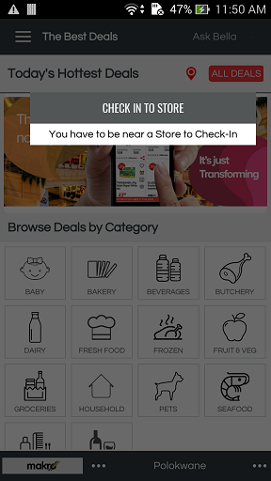
WS : http://thebestdeals.co.za/webservices/products/hot_deals_with_ads
RAW: {"store_id":"1209","longitude":"73.7351433","user_id":"453","latitude":"19.9525581","retailer_id":"47","api_key":"7e53784e66dd87004a1d0e76ff195011","device_type" :"A"}
Note : "device_type" :"A" [ "A" : Android, "I" : Apple ]
success
--------
{
"status": "Success",
"products": [
{
"reviews_count": "0",
"avg_rating": "0",
"wish_lists": "0",
"Id": "12674",
"HouseId": "0",
"ProductName": "JEYES Toilet Block Original 4 x 45g",
"ProductImage": "http://thebestdeals.co.za/assets/images/products/medium/JEYES_Toilet_Block_Original_4_x_45g.jpg",
"ProductDescription": "JEYES Toilet Block Original 4 x 45g",
"RRP": "36.95",
"Brand": "JEYES",
"SKU": "",
"store_price": "36.95",
"SpecialQty": "3",
"SpecialPrice": "80.00",
"BasketId": "959",
"price_alert": "0",
"PriceAppliedFrom": "01 Apr",
"PriceAppliedTo": "30 Jun",
"IsStore": "0",
"special_id": "99",
"is_favorite": 0,
"PageUrl": "http://thebestdeals.co.za/productdetails/JEYES+Toilet+Block+Original+4+x+45g/dHCH4utTr1aCrixsvejC4JHbT74y47DTwPBHPbiBgJVZKIbjk4aMx~Uu2ckRbzZVZLKF6LtQ.RoBfMkOyhckXA--",
"item_type": "Product"
}
]
}

Get Advertisements
WS :http://thebestdeals.co.za/webservices/categories/get_advertisements
RAW: {"api_key":"7e53784e66dd87004a1d0e76ff195011", "category_id":"343"}
success
--------
{
"status": "Success",
"message": "Advertisement(s) available",
"advertisements": [
{
"Id": "3",
"MainCategoryId": "343",
"AdvertisementTitle": "Ads 3",
"AdvertisementImage": "http://thebestdeals.co.za/assets/images/advertisements/original/1080x450-Mall3.jpg",
"AdvertisementDescription": "Description for Ad",
"AdvertisementUrl": "http://www.thebestdeals.co.za/advertisements/ad3"
}
]
}

Search
1) Search(http://thebestdeals.co.za/webservices/search/search_product)
2) Search product categories by product name (http://thebestdeals.co.za/webservices/search/search_product)
3) Search product based on categories
http://thebestdeals.co.za/webservices/search/search_product_by_category
3) Search product for shopping list
http://thebestdeals.co.za/webservices/search/shopping_list_search_product
--------------------------------------------------------------------------

Search Product [ Not In Use ]
------
WS : http://thebestdeals.co.za/webservices/search/search_product
RAW: {"user_id":"77","search_text":"egg","api_key":"7e53784e66dd87004a1d0e76ff195011"
,"device_type" :"A","retailer_id":"47","store_id":"1209"}

success
--------
{
"status": "Success",
"product_details": [
{
"Id": "1849",
"ProductName": "Albany Superior Brown Bread 700g",
"ProductImage": "http://thebestdeals.co.za/assets/images/products/medium/default.jpg",
"ProductDescription": "Albany Superior Brown Bread 700g",
"RRP": "11.99",
"Brand": "Albany",
"SKU": "",
"reviews_count": "0",
"avg_rating": "0",
"is_favorite": "0",
"store_price": "12.00",
"SpecialQty": "0",
"SpecialPrice": "0"
}
],
"total_pages": 1,
"products_range": []
}

Fail
-----
{
"status": "Success",
"total_pages": 0,
"products": [],
"products_range": []
}

Search Product Categories by Product Name
------
WS : http://thebestdeals.co.za/webservices/search/search_product_categories
RAW: {"api_key":"7e53784e66dd87004a1d0e76ff195011","user_id":"77","search_text":"nestle"}
success
--------
{
"status": "Success",
"categories": [
{
"ProductCategoryName": "Desserts",
"ProductCategoryId": "405",
"ProductCount": 1
},
{
"ProductCategoryName": "Teas, Coffees & Creamers",
"ProductCategoryId": "195",
"ProductCount": 27
}
],
"basket_count": "19"
}

Fail
-----
{
"status": "Success",
"categories": []
}

Search Product based on Categories
------
WS : http://thebestdeals.co.za/webservices/search/search_product_by_category
RAW: { "api_key":"7e53784e66dd87004a1d0e76ff195011", "user_id":"77", "search_text":"nestle" ,"category_id":"153","device_type" :"A","retailer_id":"47","store_id":"1209"}
Note : "device_type" :"A" [ "A" : Android, "I" : Apple ]
success
--------
{ "status": "Success",
"product_details": [
{
"reviews_count": "0",
"avg_rating": "0",
"Id": "6593",
"ProductName": "NESTLE Cheerios Honey 490g",
"ProductImage": "http://thebestdeals.co.za/assets/images/products/medium/NESTLE_Cheerios_Honey_490g1.jpg",
"ProductDescription": "NESTLE Cheerios Honey 490g",
"RRP": "34.95",
"Brand": "NESTLE",
"SKU": "",
"store_price": "34.99",
"PriceAppliedFrom": "01 Apr",
"PriceAppliedTo": "30 Jun",
"IsStore": "0",
"special_id": "99",
"ProductCategoryName": "Cereals Breakfast Cereals",
"ProductCategoryId": "153",
"SpecialQty": "3",
"SpecialPrice": "90.00",
"is_favorite": 0,
"PageUrl": "https://play.google.com/store/apps/details?id=com.thebestdeals"
}
],
"basket_count": "19"
}
Fail
-----
{
"status": "Success",
"product_details": []
}
-------------------------------------------------------------------------------------------------------------
-------------------------------------------------------------------------------------------------------------

Search Product for shopping list [ Not In Use]

WS : http://thebestdeals.co.za/webservices/search/shopping_list_search_product
RAW: {"user_id":"77","search_text":"egg","api_key":"7e53784e66dd87004a1d0e76ff195011","device_type" :"I","retailer_id":"47","store_id":"1209"}
Note : "device_type" :"A" [ "A" : Android, "I" : Apple ]
success
--------
{
"status": "Success",
"product_details": [
{
"reviews_count": "0",
"avg_rating": "0",
"Id": "13015",
"ProductName": "Aero Bubbles Filled Chocolate Egg 124g",
"ProductImage": "http://thebestdeals.co.za/assets/images/products/medium/NESTLE_Aero_Bubbles_Filled_Chocolate_Egg_124g.jpg",
"ProductDescription": "NESTLE Aero Bubbles Filled Chocolate Egg 124g",
"RRP": "49.99",
"Brand": "NESTLE",
"SKU": "",
"store_price": "49.99",
"PriceAppliedFrom": "",
"PriceAppliedTo": "",
"IsStore": "0",
"special_id": "0",
"SpecialQty": "0",
"SpecialPrice": "0",
"is_favorite": 0,
"PageUrl": "https://play.google.com/store/apps/details?id=com.thebestdeals"
},
{
"reviews_count": "0",
"avg_rating": "0",
"Id": "13009",
"ProductName": "After Eight Chocolate Egg 234g",
"ProductImage": "http://thebestdeals.co.za/assets/images/products/medium/NESTLE_After_Eight_Chocolate_Egg_234g.jpg",
"ProductDescription": "NESTLE After Eight Chocolate Egg 234g",
"RRP": "105.99",
"Brand": "NESTLE",
"SKU": "",
"store_price": "105.99",
"PriceAppliedFrom": "",
"PriceAppliedTo": "",
"IsStore": "0",
"special_id": "0",
"SpecialQty": "0",
"SpecialPrice": "0",
"is_favorite": 0,
"PageUrl": "https://play.google.com/store/apps/details?id=com.thebestdeals"
}
],
"total_pages": 1,
"products_range": [],
"next": 20,
"basket_count": "1"
}
-------------------------------------------------------------------------------------------------------------
-------------------------------------------------------------------------------------------------------------

Users
1) login (http://thebestdeals.co.za/webservices/users/login)
2) Update fb email if not fount on login (http://thebestdeals.co.za/webservices/users/update_fb_email)
3) Check email id is available against the given fb id (http://thebestdeals.co.za/webservices/users/check_fb_email)
4) To ckeck fb account already exists (http://thebestdeals.co.za/webservices/users/check_fb_account)
5) To check the email id present anywhere in the DB (http://thebestdeals.co.za/webservices/users/check_email)
6) To check the preferred location is set (http://thebestdeals.co.za/webservices/users/check_preffered_location)
7) To save the preferred location (http://thebestdeals.co.za/webservices/users/save_preffered_location)
8) Get the user details (http://thebestdeals.co.za/webservices/users/get_user_details)
9) Set user settings/notification settings (http://thebestdeals.co.za/webservices/users/save_user_setting)
10) Get user settings/notification settings (http://thebestdeals.co.za/webservices/users/get_user_setting)
11) Update profile settings (http://thebestdeals.co.za/webservices/users/edit)
12) Logout and remove the device token (http://thebestdeals.co.za/webservices/users/logout)
13) Change the password (http://thebestdeals.co.za/webservices/users/change_password)
14) Forgot password (http://thebestdeals.co.za/webservices/users/forget_password)
15) Registration (http://thebestdeals.co.za/webservices/users/registration)
16) States (http://thebestdeals.co.za/webservices/users/states)

Login
------
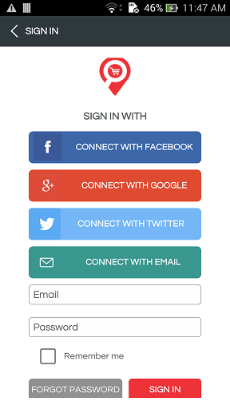
WS : http://thebestdeals.co.za/webservices/users/login

Normal login
-------------
RAW: {"api_key":"7e53784e66dd87004a1d0e76ff195011","email": "","password":"","sign_from":"W","device_token":"devicetoken","device_type":""}

Facebook login
-------------
RAW: {"api_key":"7e53784e66dd87004a1d0e76ff195011","email": "","first_name":"","last_name":"","sign_from":"F","device_token":"devicetoken","device_type":""}

Twitter login
-------------
RAW: {"api_key":"7e53784e66dd87004a1d0e76ff195011","email": "","first_name":"","last_name":"","screen_name":"","sign_from":"T","device_token":"devicetoken","device_type":""}

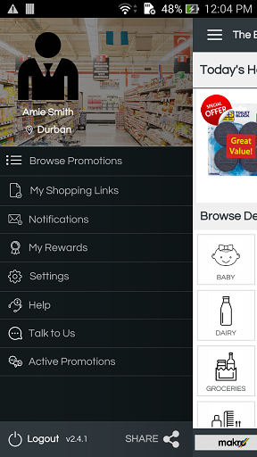
-----------------------------------------------------------------------------------------------------------------------------
-----------------------------------------------------------------------------------------------------------------------------

Update FB Email if not found on Login
-----------------------------------

WS : http://thebestdeals.co.za/webservices/users/update_fb_email
RAW: {"api_key":"7e53784e66dd87004a1d0e76ff195011","fb_uid":"1467073309976225","email": ""}

SUCCESS
-------
{
"status": "Success",
"message": "Email updated successfully.",
{
"email":""
}
}

FAIL
-----
{
"status": "Fail",
"message": "Failed to update email.",
{
"email":""
}
}

-----------------------------------------------------------------------------------------------------------------------------
-----------------------------------------------------------------------------------------------------------------------------

Check Email ID is available against the given FB ID
-----------------------------------

WS : http://thebestdeals.co.za/webservices/users/check_fb_email
RAW: {"api_key":"7e53784e66dd87004a1d0e76ff195011","fb_uid":"1467073309976225"}

SUCCESS
-------
{
"status": "Success",
"message": "Email id is available",
{
"email":""
}
}

FAIL
-----
{
"status": "Fail",
"message": "Email id not available",
{
"email":""
}
}

-----------------------------------------------------------------------------------------------------------------------------
-----------------------------------------------------------------------------------------------------------------------------

To check if FB Account already exists
-----------------------------------

WS : http://thebestdeals.co.za/webservices/users/check_fb_account
RAW: {"api_key":"7e53784e66dd87004a1d0e76ff195011","fb_uid":"1467073309976225"}

SUCCESS
-------
{
"status": "Success",
"message": "The facebook account already exists."
}

FAIL
-----
{
"status": "Fail",
"message": "The facebook account is not available."
}

-----------------------------------------------------------------------------------------------------------------------------
-----------------------------------------------------------------------------------------------------------------------------

To check if Email ID is present anywhere in the DB
--------------------------------------------------

WS : http://thebestdeals.co.za/webservices/users/check_email
RAW: {"api_key":"7e53784e66dd87004a1d0e76ff195011","email":"arunsankars1989@gmail.com"}

SUCCESS
-------
{
"status": "Success",
"message": "The email already exists."
}

FAIL
-----
{
"status": "Fail",
"message": "Email not found."
}

-----------------------------------------------------------------------------------------------------------------------------
-----------------------------------------------------------------------------------------------------------------------------

To check the Preferred Location is set
--------------------------------------------------

WS : http://thebestdeals.co.za/webservices/users/check_preffered_location
RAW: {"api_key":"7e53784e66dd87004a1d0e76ff195011","user_id":"202"}

SUCCESS
-------
{
"status": "Success",
"states": "Preferred location is set.",
"latlong": {
"PrefLatitude": "-29.8582",
"PrefLongitude": "31.0201"
}
}

FAIL
-----
{
"status": "Fail",
"message": "Preferred location is not set."
}

-----------------------------------------------------------------------------------------------------------------------------
-----------------------------------------------------------------------------------------------------------------------------

To SAVE the Preferred Location
--------------------------------------------------

WS : http://thebestdeals.co.za/webservices/users/save_preffered_location
RAW: {"api_key":"7e53784e66dd87004a1d0e76ff195011","user_id":"202","latitude":"","longitude":"","distance":""}

SUCCESS
-------
{
"status": "Success",
"states": "Preferred location updated successfully.",
}

FAIL
-----
{
"status": "Fail",
"message": "Failed to update preferred location."
}

-----------------------------------------------------------------------------------------------------------------------------
-----------------------------------------------------------------------------------------------------------------------------

Get the User Details
--------------------------------------------------
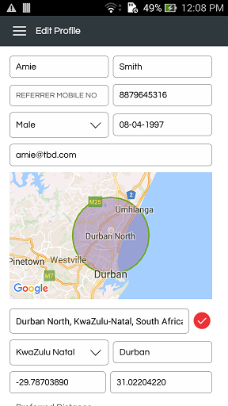
WS : http://thebestdeals.co.za/webservices/users/get_user_details
RAW: {"user_id":"77","api_key":"7e53784e66dd87004a1d0e76ff195011"}

SUCCESS
-------
{
"status": "Success",
"user_details": {
"Id": "77",
"FirstName": "AmiiE",
"LastName": "JaksoN",
"Email": "amie@tbd.com",
"ProfileImage": "http://thebestdeals.co.za/assets/images/users/medium/boss-512.png",
"HouseNumber": "232",
"StreetAddress": "College Road",
"City": "Cape Town",
"Suburb": "2321323",
"state": "KwaZulu Natal",
"PinCode": "8001",
"TelephoneFixed": "2313123232",
"Mobile": "3242342342",
"Gender": "M",
"DateOfBirth": "01-01-1970"
}
}

FAIL
-----
{
"status": "Fail",
"message": "No details found",
"user_details": []
}

-----------------------------------------------------------------------------------------------------------------------------
-----------------------------------------------------------------------------------------------------------------------------

Set User Settings / Notification Settings
--------------------------------------------------

WS : http://thebestdeals.co.za/webservices/users/save_user_setting
RAW: {"user_id":"202","wishlist_notification":"","favorite_notification":"","other_notification":"","api_key":"7e53784e66dd87004a1d0e76ff195011"}

SUCCESS
-------
{
"status": "Success",
"message": "Settings saved successfully",
}

FAIL
-----
{
"status": "Fail",
"message": "Error in saving your settings"
}

-----------------------------------------------------------------------------------------------------------------------------
-----------------------------------------------------------------------------------------------------------------------------

Get User Settings / Notification Settings
--------------------------------------------------

WS : http://thebestdeals.co.za/webservices/users/get_user_setting
RAW: {"user_id":"202","api_key":"7e53784e66dd87004a1d0e76ff195011"}

SUCCESS
-------
{
"status": "Success",
"user_details": {
"id": "2",
"UserId": "97",
"WishlistNotification": "1",
"FavoriteNotification": "1",
"OtherRetailer": "0"
}
}

FAIL
-----
{
"status": "Success",
"user_details": ""
}

-----------------------------------------------------------------------------------------------------------------------------
-----------------------------------------------------------------------------------------------------------------------------

Update Profile Settings
--------------------------------------------------

WS : http://thebestdeals.co.za/webservices/users/edit
RAW: {"user_id":"30","first_name":"","last_name":"","telephone_fixed":"","telephone_mob":"","street_name":"","city":"","province":"","latitude":"","longitude":"","dob":"","gender":"","api_key":"7e53784e66dd87004a1d0e76ff195011"}

SUCCESS
-------
{
"status": "Success",
"message":"Profile updated successfully.",
"userDetails": {
"FirstName": "",
"LastName": "",
"HouseNumber": "",
"StreetAddress": "",
"Suburb": "",
"city": "",
"State": "",
"Country": "",
"PinCode": "",
"Latitude": "",
"Longitude": "",
"TelephoneFixed": "",
"Mobile": "",
"ModifiedOn": "",
"DateOfBirth": "",
"Gender": "",

}
}

FAIL
-----
{
"status": "Fail",
"message":"Failed to update profile.",
"userDetails": {
"FirstName": "",
"LastName": "",
"HouseNumber": "",
"StreetAddress": "",
"Suburb": "",
"city": "",
"State": "",
"Country": "",
"PinCode": "",
"Latitude": "",
"Longitude": "",
"TelephoneFixed": "",
"Mobile": "",
"ModifiedOn": "",
"DateOfBirth": "",
"Gender": "",

}
}

-----------------------------------------------------------------------------------------------------------------------------
-----------------------------------------------------------------------------------------------------------------------------

Logout and REMOVE the device token
--------------------------------------------------
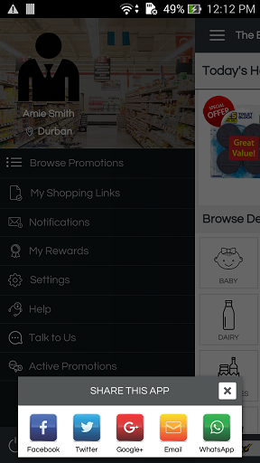
WS : http://thebestdeals.co.za/webservices/users/logout
RAW: {"user_id":"77","device_token": "dJ9AV_CtV6U:APA91bG13B4DaFvGv2CU3Ral42cMnfJS9jXK5voxQjDuE1dZJp9Hnvo8EbIlkqdv-gZtTHnjfhwSgUjPXbxB_FkMny60KzvlboJiacecLoi5GTe4ht6bQOSMGXBDObubotw-76zM56h-", "api_key":"7e53784e66dd87004a1d0e76ff195011"}

SUCCESS
-------
{
"status": "Success"
}

FAIL
-----
{
"status": "Fail"
}

-----------------------------------------------------------------------------------------------------------------------------
-----------------------------------------------------------------------------------------------------------------------------

Change Password
--------------------------------------------------

WS : http://thebestdeals.co.za/webservices/users/change_password
RAW: {"user_id":"77","old_password": "","new_password": "", "api_key":"7e53784e66dd87004a1d0e76ff195011"}

SUCCESS
-------
{
"status": "Success",
"message": "Profile updated password."
}

FAIL
-----
{
"status": "Fail",
"message": "Failed to update password."
}

or

{
"status": "Fail",
"message": "Old password is invalid."
}

-----------------------------------------------------------------------------------------------------------------------------
-----------------------------------------------------------------------------------------------------------------------------

Forgot Password
--------------------------------------------------

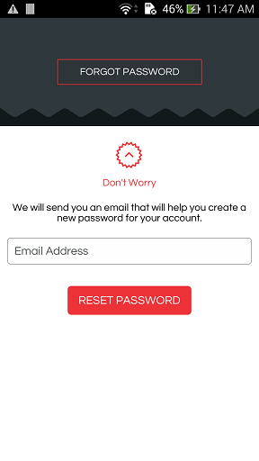
WS : http://thebestdeals.co.za/webservices/users/forget_password
RAW: {"email":"", "api_key":"7e53784e66dd87004a1d0e76ff195011"}

SUCCESS
-------
{
"status": "Success",
"message": "Email sent successfully."
}

FAIL
-----
{
"status": "Fail",
"message": "Something went wrong, could not send mail."
}

or

{
"status": "Fail",
"message": "Sorry, your account awaits admin approval."
}

or

{
"status": "Fail",
"message": "Email not found."
}

or

{
"status": "Fail",
"message": "Please enter a valid email."
}

-----------------------------------------------------------------------------------------------------------------------------
-----------------------------------------------------------------------------------------------------------------------------

Registration
--------------------------------------------------
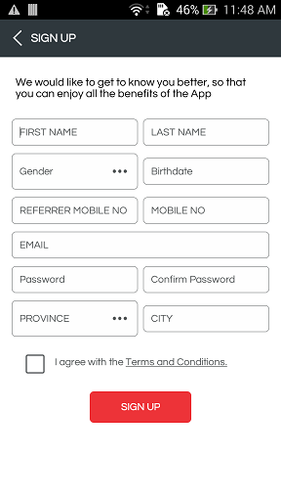
WS : http://thebestdeals.co.za/webservices/users/registration
RAW: {"email":"","first_name":"","last_name":"","telephone_fixed":"", "telephone_mob":"", "password":"", "street_name":"", "city":"", "province":"", "latitude":"", "longitude":"", "dob":"", "gender":"", "device_token":"","device_type":"", "api_key":"7e53784e66dd87004a1d0e76ff195011"}

SUCCESS
-------
{
"status": "Success",
"UserId":"",
"message": "Registration successful.",
"userDetails": [
[
{
"FirstName":"",
"LastName":"",
"Email":"",
"Password":"",
"StreetAddress":"",
"city":"",
"State":"",
"Country":"",
"Latitude":"",
"UserRole":"",
"Longitude":"",
"TelephoneFixed":"",
"Mobile":"",
"CreatedOn":"",
"DateOfBirth":"",
"Gender":""
}
]
]
}

FAIL
-----
{
"status": "Fail",
"message": "Registration failed.",
"userDetails": [
[
{
"FirstName":"",
"LastName":"",
"Email":"",
"Password":"",
"StreetAddress":"",
"city":"",
"State":"",
"Country":"",
"Latitude":"",
"UserRole":"",
"Longitude":"",
"TelephoneFixed":"",
"Mobile":"",
"CreatedOn":"",
"DateOfBirth":"",
"Gender":""
}
]
]
}

or

{
"status": "Fail",
"message": "The email already exists."
}

States
--------------------------------------------------

WS : http://thebestdeals.co.za/webservices/users/states
RAW: {api_key":"7e53784e66dd87004a1d0e76ff195011"}

SUCCESS
-------
{
"status": "Success",
"states": [
{
"Id": "1",
"Name": "Western Cape",
"CountryId": "1",
"StateCode": "za-wc",
"CreatedOn": "2015-09-02 00:00:00",
"ModifiedOn": "2015-09-02 00:00:00",
"IsActive": "1",
"IsRemoved": "0"
},
{
"Id": "2",
"Name": "KwaZulu Natal",
"CountryId": "1",
"StateCode": "za-nl",
"CreatedOn": "0000-00-00 00:00:00",
"ModifiedOn": "0000-00-00 00:00:00",
"IsActive": "1",
"IsRemoved": "0"
}
]
}

Wishlist
1) List the Wish List for a particular user (http://thebestdeals.co.za/webservices/wishlist/list)
2) Get Wish list product (http://thebestdeals.co.za/webservices/wishlist/list_wishlist_product)
3) Delete Wish List (http://thebestdeals.co.za/webservices/wishlist/delete)
4) Delete Wish List product (http://thebestdeals.co.za/webservices/wishlist/delete_product_wishlist)
5) Create Wish List (http://thebestdeals.co.za/webservices/wishlist/create)
6) Update a Wish List (http://thebestdeals.co.za/webservices/wishlist/update)
7) Add product to Wish List (http://thebestdeals.co.za/webservices/wishlist/add_product_wishlist)
-----------------------------------------------------------------

List the Wishlist for a particular User
------

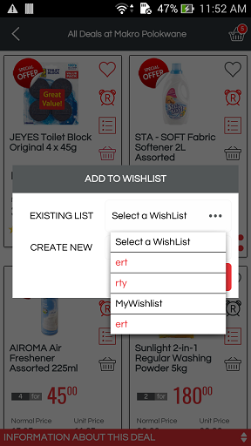
WS : http://thebestdeals.co.za/webservices/wishlist/list
RAW: {"user_id":212,"api_key": "7e53784e66dd87004a1d0e76ff195011"}

success
--------
{
"status": "Success",
"wishlist": [
{
"Id": "23",
"WishlistDescription": "Juice",
"products_count": "1",
"CreatedOn": "25/10/2016"
}
]
}

Fail
-----
{
"status": "Success",
"wishlist": []
}

-------------------------------------------------------------------------------------
-------------------------------------------------------------------------------------

Get Wishlist Product
------
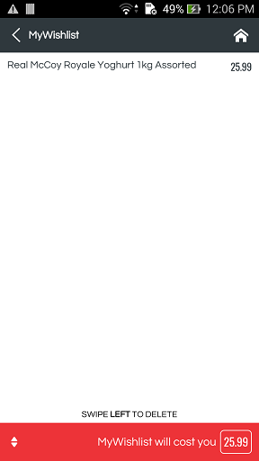
WS : http://thebestdeals.co.za/webservices/wishlist/list_wishlist_product
RAW: {"user_id":212,"wishlist_id":23,"api_key": "7e53784e66dd87004a1d0e76ff195011"}

success
--------
{
"status": "Success",
"wishlist_products": [
{
"ProductId": "28",
"ProductName": "Orange Grove Fruit Juice Blend 1.5L",
"ProductImage": "http://thebestdeals.co.za/assets/images/products/medium/IDShot_540x540.jpg",
"RRP": "19.99",
"ProductDescription": "Orange Grove Fruit Juice Blend 1.5L",
"reviews_count": "0",
"avg_rating": "0",
"CategoryName": null,
"RetailerId": "32",
"CompanyName": "SPAR",
"LogoImage": "http://thebestdeals.co.za/assets/images/retailers/medium/spar_logo-300B.jpg",
"StoreName": "",
"store_price": "20.00",
"SpecialQty": "6",
"SpecialPrice": "100.00"
}
]
}

Fail
-----
{
"status": "Success",
"wishlist_products": []
}

-------------------------------------------------------------------------------------
-------------------------------------------------------------------------------------

Delete Wishlist
------
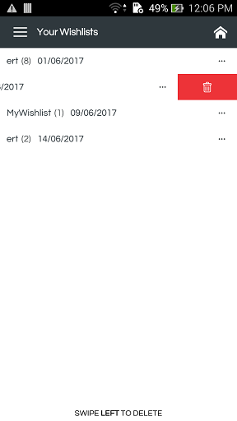
WS : http://thebestdeals.co.za/webservices/wishlist/delete
RAW: {"user_id":212,"wishlist_id":23,"api_key": "7e53784e66dd87004a1d0e76ff195011"}

success
--------
{
"status": "Success",
"wishlist": 23
}

Fail
-----
{
"status": "Fail",
"message": "Error in deleting wishlist"
}

-------------------------------------------------------------------------------------
-------------------------------------------------------------------------------------

Delete Wishlist Product
------
WS : http://thebestdeals.co.za/webservices/wishlist/delete_product_wishlist
RAW: {"user_id":212,"wishlist_id":23,"product_id":"","retailer_id":"","api_key": "7e53784e66dd87004a1d0e76ff195011"}

success
--------
{
"status": "Success",
"wishlist": true
}

Fail
-----
{
"status": "Fail",
"message": "Error in deleting product from wishlist"
}

-------------------------------------------------------------------------------------
-------------------------------------------------------------------------------------

Create Wish List
------
WS : http://thebestdeals.co.za/webservices/wishlist/create
RAW: {"user_id":212,"wishlist_name":"name","api_key": "7e53784e66dd87004a1d0e76ff195011"}

success
--------
{
"status": "Success",
"Id": "24",
"WishlistDescription":"wish list name",
"CreatedOn":"24-11-2016",
"products_count":"0"
}

Fail
-----
{
"status": "Fail",
"message": "Error in creating wishlist"
}

-------------------------------------------------------------------------------------
-------------------------------------------------------------------------------------

Update a Wishlist
------
WS : http://thebestdeals.co.za/webservices/wishlist/update
RAW: {"user_id":212,"wishlist_id":23,"wishlist_name":"name","api_key": "7e53784e66dd87004a1d0e76ff195011"}

success
--------
{
"status": "Success",
"wishlist": "24"
}

Fail
-----
{
"status": "Fail",
"message": "Error in updating wishlist"
}

-------------------------------------------------------------------------------------
-------------------------------------------------------------------------------------

Add Product to Wishlist
------
WS : http://thebestdeals.co.za/webservices/wishlist/add_product_wishlist
RAW: {"user_id":212,"wishlist_id":23,"product_id":"1234","retailer_id":"50","store_id":"294","api_key": "7e53784e66dd87004a1d0e76ff195011"}

success
--------
{
"status": "Success",
"wishlist_product_id": "30"
}

Fail
-----
{
"status": "Fail",
"message": "Product already added to wishlist"
}

Delete Multiple Wishlists

WS : http://thebestdeals.co.za/webservices/wishlist/delete_multiple
RAW: {"wishlist_ids":"1,2,3","api_key": "7e53784e66dd87004a1d0e76ff195011"}

success
--------
{
"status": "Success"
}

Retailers
1) List all the retailers(http://thebestdeals.co.za/webservices/retailers/list)
2) Save user preference(http://thebestdeals.co.za/webservices/retailers/save_user_preference)
3) Get user preference(http://thebestdeals.co.za/webservices/retailers/get_user_preference)
4) Save store(http://thebestdeals.co.za/webservices/retailers/save_store)
5) Save preferences(http://thebestdeals.co.za/webservices/retailers/save_preferences)
6) Get retailer stores(http://thebestdeals.co.za/webservices/retailers/get_retailer_stores

List all the Retailers
------
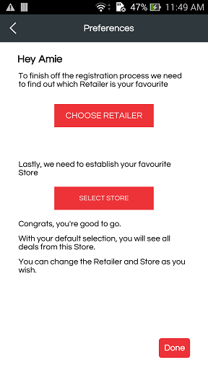
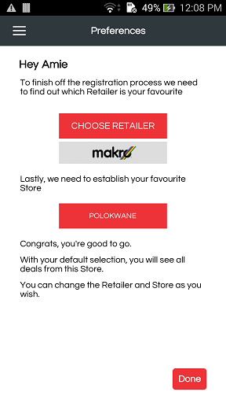
WS : http://thebestdeals.co.za/webservices/retailers/list
RAW: {"group_id":"3","api_key":"7e53784e66dd87004a1d0e76ff195011"}

success
--------
{
"status": "Success",
"retailers": [
{
"Id": "32",
"CompanyName": "SPAR",
"LogoImage": "http://thebestdeals.co.za/assets/images/retailers/medium/Spar2.jpg"
},
{
"Id": "33",
"CompanyName": "Checkers",
"LogoImage": "http://thebestdeals.co.za/assets/images/retailers/medium/Checkers3.jpg"
}
],
"store_groups": [
{
"Id": "1",
"GroupName": "Groceries"
},
{
"Id": "2",
"GroupName": "Meat"
},
{
"Id": "3",
"GroupName": "Seafood"
},
{
"Id": "4",
"GroupName": "Liquor"
},
{
"Id": "5",
"GroupName": "Pharmacy"
}
]
}

-------------------------------------------------------------------------------------------------------------
-------------------------------------------------------------------------------------------------------------

Save User Preference
------
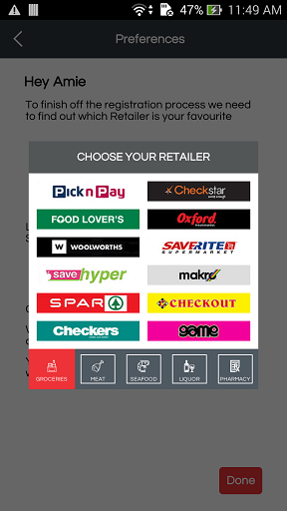
WS : http://thebestdeals.co.za/webservices/retailers/save_user_preference
RAW: {"group_id":"1","user_id":212, "retailer_id":"", "store_id":"", "latitude":"", "longitude":"", "api_key": "7e53784e66dd87004a1d0e76ff195011"}

success
--------
{
"status": "Success",
"stores": [
{

}
],
"message": "Retailer added successfully"
}

-------------------------------------------------------------------------------------------------------------
-------------------------------------------------------------------------------------------------------------

Get User Preference
------
WS : http://thebestdeals.co.za/webservices/retailers/get_user_preference
RAW: {"user_id":77,"api_key": "7e53784e66dd87004a1d0e76ff195011"}

success
--------
{
"status": "Success",
"retailer": {
"Id": "43",
"CompanyName": "GAME",
"LogoImage": "gamelogo-jpg.jpg",
"StoreName": "Westwood Mall"
}
}

-------------------------------------------------------------------------------------------------------------
-------------------------------------------------------------------------------------------------------------

Save Store
------
WS : http://thebestdeals.co.za/webservices/retailers/save_store
RAW: {"user_id":77, "store_id":"","api_key": "7e53784e66dd87004a1d0e76ff195011"}

success
--------
{
"status": "Success",
"message": "Retailer store added successfully"
}
-------------------------------------------------------------------------------------------------------------
-------------------------------------------------------------------------------------------------------------

Save preferences
------
WS : http://thebestdeals.co.za/webservices/retailers/save_preferences
RAW: { "group_id":"1", "longitude":"31.02184040", "user_id":"77", "latitude":"-29.85868040", "retailer_id":"47", "store_id":"1209", "api_key":"7e53784e66dd87004a1d0e76ff195011"
}
Note : If store_id is not passed, it will take store nearest to user based on his current location and set as default store.
success
--------
{
"status": "Success",
"stores": [
{
"StoreName": "Springfield",
"Id": "605",
"StoreTypeId": "57",
"distance": "5.81",
"storesSpecialsCount": "334",
"HaveSpecial": 1
}
],
"message": "Retailer added successfully"
}

Note : If store_id is passed, it will set as default store for the user.
{
"status": "Success",
"stores": [
{
"StoreName": "Polokwane",
"Id": "1209",
"StoreTypeId": "57",
"distance": "683.02",
"storesSpecialsCount": "334",
"HaveSpecial": 1
}
],
"message": "Retailer added successfully"
}
-------------------------------------------------------------------------------------------------------------
-------------------------------------------------------------------------------------------------------------

Get retailer stores
------
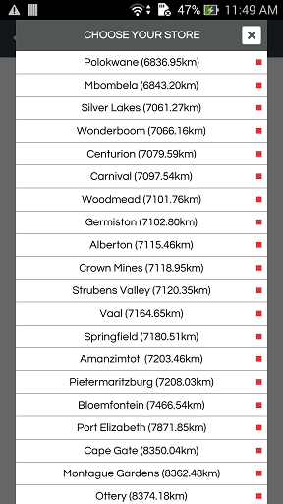
WS : http://thebestdeals.co.za/webservices/retailers/get_retailer_stores
RAW: {"group_id":"1","user_id":212, "retailer_id":"", "store_id":"", "latitude":"", "longitude":"", "api_key": "7e53784e66dd87004a1d0e76ff195011"}

success
--------
{
"status": "Success",
"stores": [
{
"StoreName": "Springfield",
"Id": "605",
"StoreTypeId": "57",
"distance": "5.81",
"storesSpecialsCount": "334",
"HaveSpecial": 1
},
{
"StoreName": "Amanzimtoti",
"Id": "606",
"StoreTypeId": "57",
"distance": "21.97",
"storesSpecialsCount": "334",
"HaveSpecial": 1
}
],
"message": "Store(s) available."
}
-------------------------------------------------------------------------------------------------------------
-------------------------------------------------------------------------------------------------------------

Loyalty Prodcuts
The main moto of the loyalty module is attact user to get loyalty points by sharing, viewing, review a product and Check-Ins to particular store.
User can buy loyalty products from the loyalty points he/she has acquires.

Get Loyalty Comsumptions
------
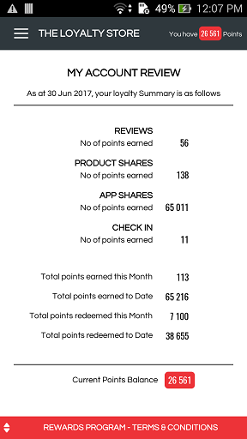
- "My Account Review" , get loyalty points consumption of the user.
WS : http://thebestdeals.co.za/webservices/loyalty/get_loyalty_consumptions
RAW: {"user_id" : 77,"api_key":"7e53784e66dd87004a1d0e76ff195011"}
success
--------
{
"status": "Success",
"termsAndConditions": "Terms and conditions 1, Terms and conditions 2, Terms and conditions 3, Terms and conditions 4, Terms and conditions 5, Terms and conditions 6, Terms and conditions 7, Terms and conditions 8, Terms and conditions 9, Electronic Goods carry the Standard Manufacturer Warranty and each item is subject to the Manufacturer\\'s Terms and Conditions of the Warranty.",
"loyaltyDetails": {
"current_date": "13 Jun 2017",
"points_earned_from_reviews": 23,
"points_earned_from_product_shares": 16,
"points_earned_from_app_shares": 40001,
"points_earned_from_checkin": 3,
"total_points_earned_this_month": 3,
"total_points_earned_to_date": 40043,
"total_points_redeemed_this_month": 0,
"total_points_redeemed_to_date": "9350",
"current_point_balance": 30693
}
}
-------------------------------------------------------------------------------------------------------------
-------------------------------------------------------------------------------------------------------------

Loyalty Product Listing
This webservice shows the listing of loyalty products. On the basis of category has been selected by users.
Beauty, Tech, Shopping and Getaways categories are available.

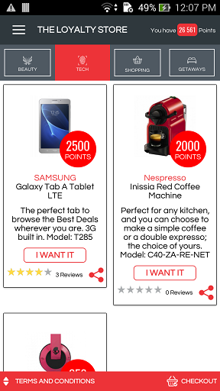
WS : http://thebestdeals.co.za/webservices/loyalty/get_loyalty_products
RAW: {"api_key":"7e53784e66dd87004a1d0e76ff195011","user_id":"77","category_id":"3",
"device_type":"A"}

success
--------
{
"status": "Success",
"balanceLoyaltyPoints": 23617,
"termsAndConditions": "All item against which points are redeemed cannot be exchanged for Cash, If Dates are specified on certain Vouchers in the Loyalty Store, then these Vouchers need to be used within those dates specified on each Voucher. Failure to do so will void the Voucher, Electronic Goods carry the Standard Manufacturer Warranty and each item is subject to the Manufacturer\\'s Terms and Conditions of the Warranty., Out of Box failures on electronic items will be replaced and swopped out. Client will have to take the item to the Nearest Store for swop out.. Client will need to contact The Best Deals first, to arrange swop out., When redeeming points again Beauty Vouchers, Client was upgrade Voucher at the Establishment, but only if the Establishment agrees. If there is a price difference, Client will have to pay in the difference., By using this app, you are subject to the Standard Terms and Conditions. E & O.E",
"loyaltyProducts": [
{
"Id": "1",
"BrandName": "SAMSUNG",
"LoyaltyTitle": "Galaxy Tab A Tablet LTE",
"ProductImage": "http://thebestdeals.co.za/assets/images/loyaltyproducts/medium/SAMSUNG_7inch_Galaxy_Tab_A_Tablet_LTE.jpg",
"LoyaltyDescription": "The perfect tab to browse the Best Deals wherever you are. 3G built in. Model: T285",
"StartDate": "2017-03-01",
"EndDate": "2017-08-31",
"LoyaltyPoints": "2500",
"CategoryName": "Tech",
"PageUrl": "https://play.google.com/store/apps/details?id=com.thebestdeals",
"isOrderPlaced": 1,
"totalReviews": "3",
"Rating": "2.5",
"Review": "nice 1"
},
{
"Id": "3",
"BrandName": "Spend it Anywhere",
"LoyaltyTitle": "R500 Shopping Experience",
"ProductImage": "http://thebestdeals.co.za/assets/images/loyaltyproducts/medium/FNB_Gift_Card_R500.jpg",
"LoyaltyDescription": "You earned it, Now its time to spend it. Anyware",
"StartDate": "2017-03-01",
"EndDate": "2017-06-30",
"LoyaltyPoints": "650",
"CategoryName": "Shopping",
"PageUrl": "https://play.google.com/store/apps/details?id=com.thebestdeals",
"isOrderPlaced": 1,
"totalReviews": "2",
"Rating": "4.0",
"Review": "cxxttty"
}
]
}
-------------------------------------------------------------------------------------------------------------
-------------------------------------------------------------------------------------------------------------

Save Users rating for the Loyalty Product
User can able to gives his/her review and rating for the particular loyalty prtoduct.
WS : http://thebestdeals.co.za/webservices/loyalty/save_loyalty_product_review_rating
RAW : {"api_key":"7e53784e66dd87004a1d0e76ff195011","user_id":"77","loyalty_product_id":"2","rating":"2","review":"The Review text will come here."}

success
--------
{
"status": "Success",
"message": "Review and Rating saved successfully.",
"loyaltyProductDetails": {
"Id": "2",
"BrandName": "Mangwanani Spa",
"LoyaltyTitle": "R500 Beauty Gift Voucher",
"ProductImage": "mangwanani_gift_voucher_R500.jpg",
"LoyaltyDescription": "Treat yourself to any one of your favourite treatments to the value of R500 from Mangwanai Spa",
"StartDate": "2017-03-01",
"EndDate": "2017-03-31",
"LoyaltyPoints": "600"
},
"reviewsAndRatings": {
"totalReviewsAndRatings": "3",
"Rating": "2",
"Review": "The Review text will come here."
}
}
-------------------------------------------------------------------------------------------------------------
-------------------------------------------------------------------------------------------------------------

Save Users Review and Rating for the Loyalty Product
WS : http://thebestdeals.co.za/webservices/loyalty/save_loyalty_product_review_rating
RAW:{"api_key":"7e53784e66dd87004a1d0e76ff195011","user_id":"77","loyalty_product_id":"2", "rating":"2","review":"The Review text will come here."}

success
--------
{
"status": "Success",
"message": "Review and Rating saved successfully.",
"loyaltyProductDetails": {
"Id": "2",
"BrandName": "Mangwanani Spa",
"LoyaltyTitle": "R500 Beauty Gift Voucher",
"ProductImage": "mangwanani_gift_voucher_R500.jpg",
"LoyaltyDescription": "Treat yourself to any one of your favourite treatments to the value of R500 from Mangwanai Spa",
"StartDate": "2017-03-01",
"EndDate": "2017-03-31",
"LoyaltyPoints": "600"
},
"reviewsAndRatings": {
"totalReviewsAndRatings": "3",
"Rating": "2",
"Review": "The Review text will come here."
}
}
-------------------------------------------------------------------------------------------------------------
-------------------------------------------------------------------------------------------------------------

Get Reviews and Rating for the Loyalty Product
WS : http://thebestdeals.co.za/webservices/loyalty/get_loyalty_products_reviews
RAW :{"api_key":"7e53784e66dd87004a1d0e76ff195011","user_id":"77","product_id":"2"}

success
--------

{
"status": "Success",
"reviews": [
{
"Id": "15",
"Review": "The Review text will come here.Second Review",
"Rating": "3",
"CreatedOn": "3 months ago",
"UserId": "77",
"FirstName": "Amie",
"LastName": "Smith",
"ProfileImage": "http://thebestdeal.co.za/assets/images/users/medium/boss-512.png"
},
{
"Id": "14",
"Review": "The Review text will come here.",
"Rating": "4",
"CreatedOn": "3 months ago",
"UserId": "78",
"FirstName": "John",
"LastName": "Tim",
"ProfileImage": "http://thebestdeal.co.za/assets/images/users/medium/Chrysanthemum.jpg"
}
]
}
-------------------------------------------------------------------------------------------------------------
-------------------------------------------------------------------------------------------------------------

Share Loyalty Product
User can share loyalty product to Facebook, Twitter, Google+ , Email and Whatsup.
WS : http://thebestdeals.co.za/webservices/loyalty/save_loyalty_product_share
RAW: {"api_key":"7e53784e66dd87004a1d0e76ff195011","user_id":"77","loyalty_product_id":"2", "share_from":"A"}
success
--------
{
"status": "Success",
"count": "11",
"message": "Share count updated successfully"
}
-------------------------------------------------------------------------------------------------------------
-------------------------------------------------------------------------------------------------------------

Add Loyalty Product into Cart
User can able to add loyalty product into shopping cart, loyalty points get reducted by the product price from his accumulated loyalty points.
WS : http://thebestdeals.co.za/webservices/loyalty/add_to_loyalty_cart
RAW :{"api_key":"7e53784e66dd87004a1d0e76ff195011","user_id":"77","loyalty_product_id":"3","points_used":"650"}

success
--------
{
"status": "Success",
"message": "Product successfully added into cart.",
"balanceLoyaltyPoints": 59199
}

Fail
--------
{
"status": "Fail",
"message": "Sorry, you don't have enough loyalty points to get this product."
}
-------------------------------------------------------------------------------------------------------------
-------------------------------------------------------------------------------------------------------------

Get Cart Product Listing
This webservice gives the loyalty product listing which user has added into his shopping cart.
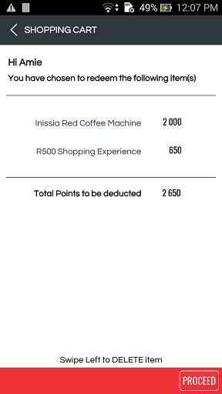

WS : http://thebestdeals.co.za/webservices/loyalty/get_cart_loyalty_products
RAW : {"api_key":"7e53784e66dd87004a1d0e76ff195011","user_id":"77","category_id":"3"
,"device_type":"A"}
Note : "device_type" :"A" [ "A" : Android, "I" : Apple ]
success
--------
{
"status": "Success",
"balanceLoyaltyPoints": 56749,
"termsAndConditions": "Terms and conditions 1, Terms and conditions 2, Terms and conditions 3, Terms and conditions 4, Terms and conditions 5, Terms and conditions 6, Terms and conditions 7, Terms and conditions 8, Terms and conditions 9, Electronic Goods carry the Standard Manufacturer Warranty and each item is subject to the Manufacturer\\'s Terms and Conditions of the Warranty.",
"cartProducts": [
{
"Id": "16",
"UserId": "77",
"LoyaltyProductId": "1",
"PointsUsed": "2500",
"productId": "1",
"BrandName": "Nespresso",
"LoyaltyTitle": "Espresso Machine",
"ProductImage": "http://thebestdeal.co.za/assets/images/loyaltyproducts/medium/1.jpg",
"LoyaltyDescription": "Perfect for any kitchen, and you can choose to make a simple coffee or a double expresso; the choice of yours.",
"StartDate": "2017-02-15",
"EndDate": "2017-03-15",
"LoyaltyPoints": "2500",
"CategoryName": "Tech",
"PageUrl": "https://play.google.com/store/apps/details?id=com.thebestdeals"
},
{
"Id": "17",
"UserId": "77",
"LoyaltyProductId": "3",
"PointsUsed": "1000",
"productId": "3",
"BrandName": "Checkers",
"LoyaltyTitle": "R2000 Voucher",
"ProductImage": "http://thebestdeal.co.za/assets/images/loyaltyproducts/medium/3.jpg",
"LoyaltyDescription": "You earned it, now its time to spend it.",
"StartDate": "2017-02-15",
"EndDate": "2017-03-15",
"LoyaltyPoints": "1000",
"CategoryName": "Getaways",
"PageUrl": "https://play.google.com/store/apps/details?id=com.thebestdeals"
}
],
"user_details": {
"Id": "77",
"FirstName": "Amie",
"LastName": "Smith",
"TelephoneFixed": " ",
"Mobile": "8879645316",
"Email": "amie@tbd.com",
"StreetAddress": "Durban, KwaZulu-Natal, South Africa",
"PrefLatitude": "-29.85868040",
"PrefLongitude": "31.02184040",
"PrefDistance": "100",
"ProfileImage": "http://thebestdeal.co.za/assets/images/users/medium/boss-512.png",
"HouseNumber": "",
"City": "Durban city",
"Suburb": "",
"state_id": "10",
"state": "North West",
"PinCode": "",
"Gender": "F",
"DateOfBirth": "16-04-2009"
}
}

Fail
--------
{
"status": "Fail",
"message": "No product found"
}
-------------------------------------------------------------------------------------------------------------
-------------------------------------------------------------------------------------------------------------

Remove Product(s) from Cart
User can able to remove the product from this cart, the amount for the product get deducted from the cart total and get increase in total loyalty points.
Single or multiple products can be remove from the cart.
WS : http://thebestdeals.co.za/webservices/loyalty/remove_cart_loyalty_product
RAW : {"cart_ids":"7","user_id" : 77,"api_key":"7e53784e66dd87004a1d0e76ff195011"}
{"cart_ids":"7,8,9","user_id" : 77,"api_key":"7e53784e66dd87004a1d0e76ff195011"}

success
--------
{
"status": "Success",
"message": "Product successfully removed from cart.",
"balanceLoyaltyPoints": 49899
}

-------------------------------------------------------------------------------------------------------------
-------------------------------------------------------------------------------------------------------------

Place Loyalty Order
- User can able to place order by clicking on “Proceed” button
- User can set his shipping address for an order, By default shipping address is as per the register address of the user.
- User can change his shipping address if it is different than register address.

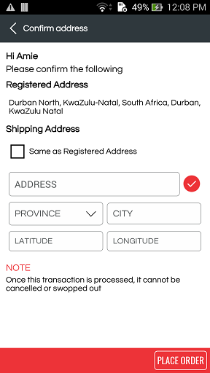
WS : http://thebestdeals.co.za/webservices/loyalty/place_loyalty_order
RAW :
{ "user_id":77,
"house_No":"",
"street_name":"Durban, KwaZulu-Natal, South Africa",
"suburb":"",
"city":"Durban",
"province":"10",
"pincode":"",
"latitude":"-29.85868040",
"longitude":"31.02184040",
"telephone_fixed":"",
"telephone_mob":"",
"api_key":"7e53784e66dd87004a1d0e76ff195011"
}
success
--------
{
"status": "Success",
"message": "Loyalty order placed successfully.",
"balanceLoyaltyPoints": 40799
}

-------------------------------------------------------------------------------------------------------------
-------------------------------------------------------------------------------------------------------------

Chatbot

The main moto of the chatbot functionality is to give the live experice of the searching. Chatbot gives us a facility that a live person is talking with us and assist us to give us a result for our searching.
In this functionlity we are search for product description/name, searching includes whole words only i.e Suppose we seach by "oil" then show products which having whole word as "oil" and not only string in the product name as "Mini Toilet Paper White 2P 4`s"
- When we come into chatbot module, first Bella will greet user and ask to enter
product description to search.
- When user enters product description, she asks whether to seach from special or normal.
- When user click on "Yes", we call webservice
http://thebestdeals.co.za/webservices/search/chatbot_search_product_categories
"api_key":"7e53784e66dd87004a1d0e76ff195011","user_id":"77","search_text":"Oil", "special_only":"yes"}
- When user click on "No", we call webservice
http://thebestdeals.co.za/webservices/search/chatbot_search_product_categories
"api_key":"7e53784e66dd87004a1d0e76ff195011","user_id":"77","search_text":"Oil"
,"special_only":"no"}
- It gives category listing for search input along with brands associated with category.
- When user selects any category from listing, it will ask to seach by Brand or by Product.
- When user select "Brand" option, it show brand listing under the selected category.
- When user select "Product" option, it show product listing under the selected category, we call webservice
http://thebestdeals.co.za/webservices/search/chatbot_search_product_categories
RAW : {"api_key":"7e53784e66dd87004a1d0e76ff195011", "user_id":"77", "search_text":"Oil", "category_id":"331","brand":"" , "product_category_id":"331", "special_only":"yes", "device_type":"I"}
- When we are seleting any product from product listing it gives brief about the selected product and it will ask user to see same product with other retailers and stores.For This we call following webservice.

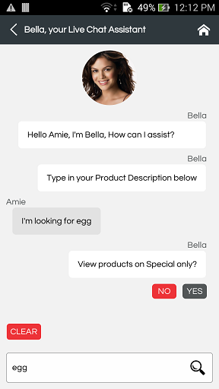
WS : http://thebestdeals.co.za/webservices/search/chatbot_get_product_stores
RAW :
{"user_id":"77","product_id":"13365","api_key":"7e53784e66dd87004a1d0e76ff195011","latitude":"-29.85868040","longitude":"31.02184040"}
- When user click on "View" button it will navigate to product details page and shows details about selected product.

Chatbot Search Product categories
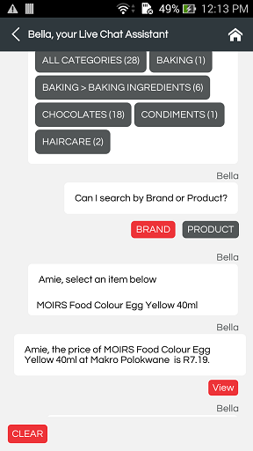
WS : http://thebestdeals.co.za/webservices/search/chatbot_search_product_categories
RAW : {"api_key":"7e53784e66dd87004a1d0e76ff195011", "user_id":"77", "search_text":"Oil" ,"special_only":"yes","retailer_id":"47","store_id":"1209"}

Note :
1) If we want to serach product which are in specials only, then we have to pass parameter "special_only":"yes".
2) If we want to serach any product, then we have to pass parameter "special_only":"no".

Purpose :
1) This WS gives us a categories of the product which are matched with the search text, whole word is considered while searching product.
2) Under each category , we are getting brands and products count of that brands matched with the search text.
3) First option is showing "ALL CATEGORIES" and under "ALL CATEGORIES" all brands are listed with product count.
4) Under "ALL CATEGORIES" first option is "ALL BRANDS" which is showing all product count under all brands matched with the searched text.

A) When search product from specials only
WS : http://thebestdeals.co.za/webservices/search/chatbot_search_product_categories
RAW : {"api_key":"7e53784e66dd87004a1d0e76ff195011" ,"user_id":"77"
,"search_text":"Oil","special_only":"yes"}

success
--------
Response
{
"status": "Success",
"categories": [
{
"ProductCategoryName": "ALL CATEGORIES",
"ProductCategoryId": 0,
"ProductCount": 3,
"brands": [
{
"BrandProductCategoryId": 0,
"BrandName": "ALL BRANDS",
"BrandProductCount": 3
},
{
"BrandProductCategoryId": "437",
"BrandName": "HEALTHCARE > ALL - INGRAMS TISSUE OIL CREAM 500ML",
"BrandProductCount": 1
},
{
"BrandProductCategoryId": "331",
"BrandName": "OIL - BASSO",
"BrandProductCount": 1
},
{
"BrandProductCategoryId": "331",
"BrandName": "OIL - ONDOLIVA",
"BrandProductCount": 1
}
]
},
{
"ProductCategoryName": "HEALTHCARE > ALL",
"ProductCategoryId": "437",
"ProductCount": 1,
"brands": [
{
"BrandProductCategoryId": "437",
"BrandName": "INGRAMS TISSUE OIL CREAM 500ML",
"BrandProductCount": 1
}
]
},
{
"ProductCategoryName": "OIL",
"ProductCategoryId": "331",
"ProductCount": 2,
"brands": [
{
"BrandProductCategoryId": "331",
"BrandName": "BASSO",
"BrandProductCount": 1
},
{
"BrandProductCategoryId": "331",
"BrandName": "ONDOLIVA",
"BrandProductCount": 1
}
]
}
],
"basket_count": "1"
}
Fail
--------
{
"status": "Success",
"categories": []
}

B) When search any product
WS : http://thebestdeals.co.za/webservices/search/chatbot_search_product_categories
RAW : {"api_key":"7e53784e66dd87004a1d0e76ff195011","user_id":"77","search_text":"Oil","special_only":"no"}

success
--------
{
"status": "Success",
"categories": [
{
"ProductCategoryName": "ALL CATEGORIES",
"ProductCategoryId": 0,
"ProductCount": 235,
"brands": [
{
"BrandProductCategoryId": 0,
"BrandName": "ALL BRANDS",
"BrandProductCount": 235
},
{
"BrandProductCategoryId": "260",
"BrandName": "ACCESSORIES - ELIZABETH ANNES",
"BrandProductCount": 1
},
{
"BrandProductCategoryId": "260",
"BrandName": "ACCESSORIES - JOHNSONS",
"BrandProductCount": 7
},
{
"BrandProductCategoryId": "359",
"BrandName": "ALL - NIVEA",
"BrandProductCount": 1
},
{
"BrandProductCategoryId": "403",
"BrandName": "BABY TOILETRIES - JOHNSON'S",
"BrandProductCount": 2
},
{
"BrandProductCategoryId": "403",
"BrandName": "BABY TOILETRIES - JOHNSONS",
"BrandProductCount": 2
}
]
},
{
"ProductCategoryName": "ACCESSORIES",
"ProductCategoryId": "260",
"ProductCount": 8,
"brands": [
{
"BrandProductCategoryId": "260",
"BrandName": "ELIZABETH ANNES",
"BrandProductCount": 1
},
{
"BrandProductCategoryId": "260",
"BrandName": "JOHNSONS",
"BrandProductCount": 7
}
]
},
{
"ProductCategoryName": "ALL",
"ProductCategoryId": "359",
"ProductCount": 1,
"brands": [
{
"BrandProductCategoryId": "359",
"BrandName": "NIVEA",
"BrandProductCount": 1
}
]
},
{
"ProductCategoryName": "BABY TOILETRIES",
"ProductCategoryId": "403",
"ProductCount": 6,
"brands": [
{
"BrandProductCategoryId": "403",
"BrandName": "JOHNSON'S",
"BrandProductCount": 2
},
{
"BrandProductCategoryId": "403",
"BrandName": "JOHNSONS",
"BrandProductCount": 2
},
{
"BrandProductCategoryId": "403",
"BrandName": "JOHNSONS BABY OIL 200ML",
"BrandProductCount": 1
},
{
"BrandProductCategoryId": "403",
"BrandName": "PURITY",
"BrandProductCount": 1
}
]
}
],
"basket_count": "1"
}

Chatbot Search Product by Category and Brand
In this we are able to search/filter product by category and brand.
Note :
- If "brand" parameter is blank then select for all brand under the category, otherwise serach for the particular brand.
- "special_only" parameter specifies , “Yes” means products from specials/promotions and “No” then show all products.
WS : http://thebestdeals.co.za/webservices/search/chatbot_search_product_by_category
RAW : {"api_key":"7e53784e66dd87004a1d0e76ff195011", "user_id":"77", "search_text":"Oil", "category_id":"331","brand":"" ,"product_category_id":"331","special_only":"yes","device_type":"A"}

success
--------
{
"status": "Success",
"user_preferred_brands": {
"RetailerId": "47",
"StoreId": "1209",
"RetailerName": "Makro",
"StoreName": "Polokwane"
},
"product_details": [
{
"reviews_count": "0",
"avg_rating": "0",
"Id": "4056",
"ProductName": "ONDOLIVA Blended Olive Oil 1L",
"ProductImage": "http://thebestdeals.co.za/assets/images/products/medium/ONDOLIVA_Blended_Olive_Oil_1L.jpg",
"ProductDescription": "ONDOLIVA Blended Olive Oil 1L",
"RRP": "51.00",
"Brand": "ONDOLIVA",
"SKU": "",
"store_price": "51.99",
"PriceAppliedFrom": "01 Apr",
"PriceAppliedTo": "30 Jun",
"IsStore": "0",
"special_id": "99",
"SpecialQty": "3",
"SpecialPrice": "120.00",
"is_favorite": 1,
"PageUrl": "https://play.google.com/store/apps/details?id=com.thebestdeals"
},
{
"reviews_count": "0",
"avg_rating": "0",
"Id": "4029",
"ProductName": "BASSO Extra Virgin Olive Oil 1L",
"ProductImage": "http://thebestdeals.co.za/assets/images/products/medium/BASSO_Extra_Virgin_Olive_Oil_1L.jpg",
"ProductDescription": "BASSO Extra Virgin Olive Oil 1L",
"RRP": "114.95",
"Brand": "BASSO",
"SKU": "",
"store_price": "114.99",
"PriceAppliedFrom": "01 Apr",
"PriceAppliedTo": "30 Jun",
"IsStore": "0",
"special_id": "99",
"SpecialQty": "2",
"SpecialPrice": "200.00",
"is_favorite": 0,
"PageUrl": "https://play.google.com/store/apps/details?id=com.thebestdeals"
}
],
"basket_count": "1"
}

Fail
--------
{
"status": "Success",
"product_details": []
}

Chatbot Get Product Stores
WS : http://thebestdeals.co.za/webservices/search/chatbot_get_product_stores
RAW : {
"status": "Success",
"stores_list": [
{
"productSpecialId": "0",
"ProductId": "13365",
"RetailerId": "32",
"StoreTypeId": "33",
"StoreId": "10020",
"ProductName": "THOKOMAN Crunchy Peanut Butter 1kg",
"RetailerName": "SPAR",
"StoreName": "Avonmore SUPERSPAR",
"SpecialQty": "0",
"SpecialPrice": "0",
"store_price": "59.99"
},
{
"productSpecialId": "0",
"ProductId": "13365",
"RetailerId": "32",
"StoreTypeId": "35",
"StoreId": "11392",
"ProductName": "THOKOMAN Crunchy Peanut Butter 1kg",
"RetailerName": "SPAR",
"StoreName": "Berea KWIKSPAR",
"SpecialQty": "0",
"SpecialPrice": "0",
"store_price": "59.99"
}
]
}

-------------------------------------------------------------------------------------------------------------
-------------------------------------------------------------------------------------------------------------

Check-In

Get Store Listing for Check-In

URL : http://thebestdeals.co.za/webservices/checkin/get_checkin_stores
RAW : {"api_key":"7e53784e66dd87004a1d0e76ff195011","user_id":"77","longitude":"30.80315351","latitude":"-27.00713764"}
Response :
{
"status": "Success",
"stores_details": [
{
"distance": "0",
"storeId": "1",
"StoreName": "Abaqulusi SUPERSPAR",
"retailerId": "32",
"retailerName": "SPAR",
"specialsCount": "1"
},
{
"distance": "0.0991629521559857",
"storeId": "1055",
"StoreName": "Church Street (Piet Retief) Family Store",
"retailerId": "34",
"retailerName": "Pick n Pay",
"specialsCount": 0
}
]
}

Fail
-----
{
"status": "Success",
"categories": []
}

Do Check-In in particular Store
URL : http://thebestdeal.co.za/webservices/checkin/get_checkin_stores
RAW : {"store_id":"580","longitude":"73.7350945","user_id":"77","latitude":"19.9526311","api_key":"7e53784e66dd87004a1d0e76ff195011"}
Response :
Response :
{
"status": "Success",
"message": "You have been successfully checked in to Shoprite Hluhluwe"
}

Fail
-----
{
"status": "Fail",
"message": "You can check in only once in an hour."
}

{
"status": "Fail",
"message": "You are not seems near to Shoprite Kokstad"
}

